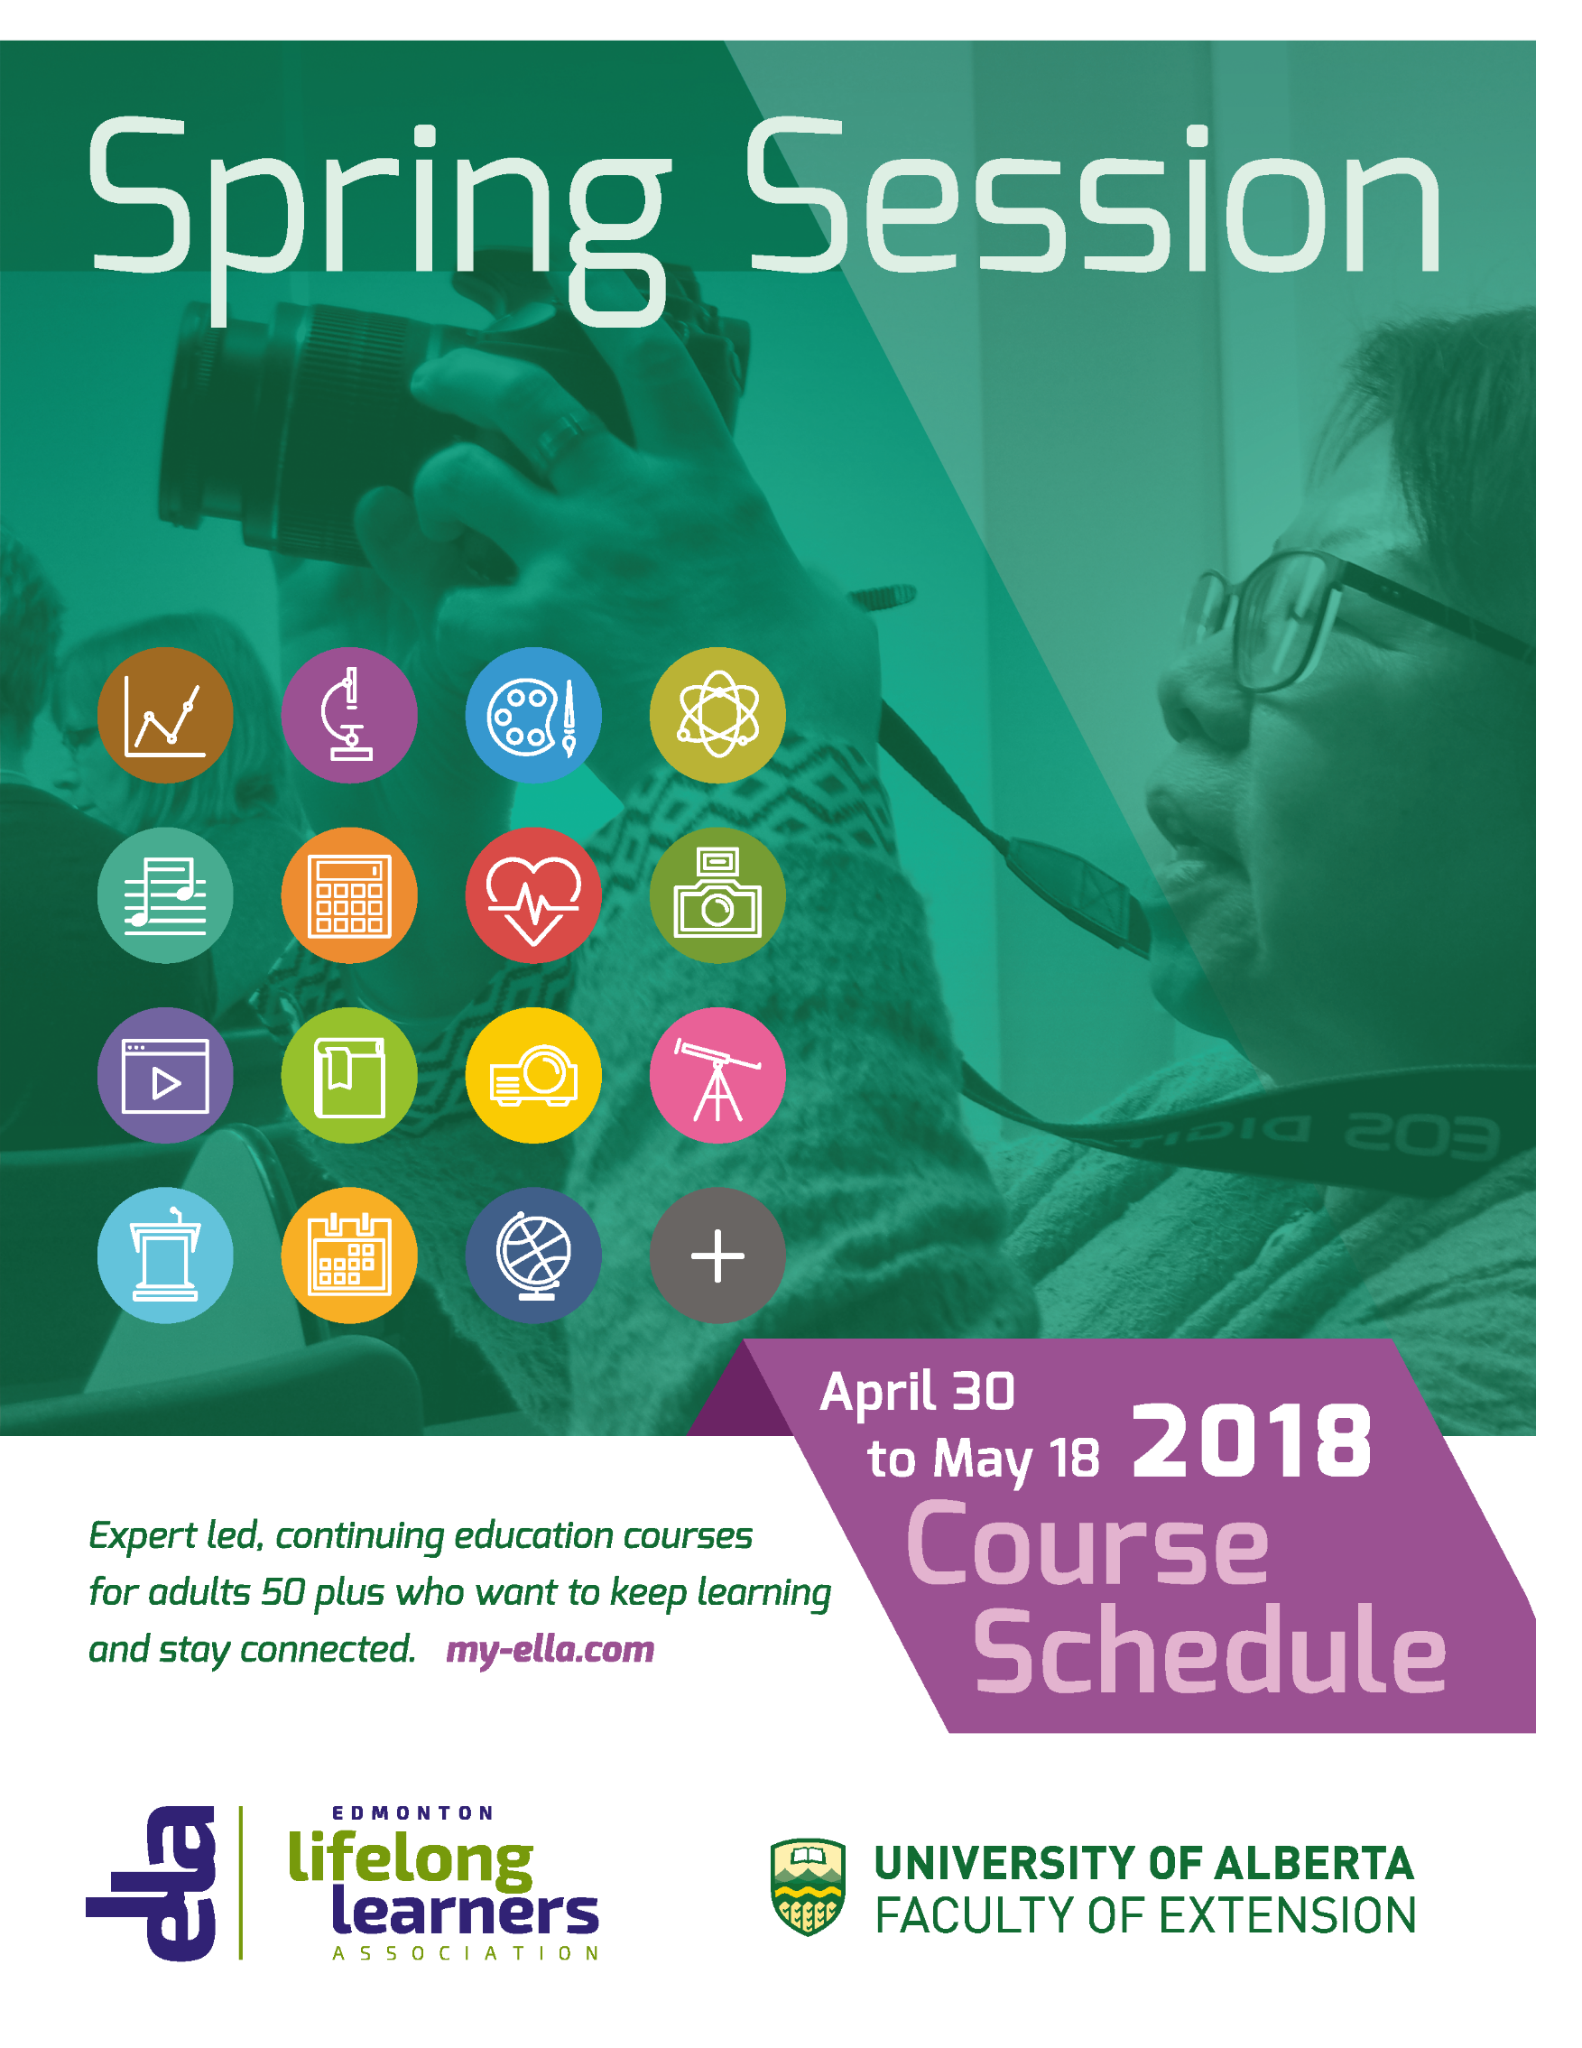
Revised

Earl Early Morning Classes - 9:00 to 10:10 a.m.
EL10 | Paleontology | Philip Currie and Eva Koppelhus
EL11 | China and Her Neighbours | Gordon Houlden
EL12 | Early Childhood Development | Ruth Collins-Nakai
EL13 | Jazz of the 1930's, '40's and '50's | Michael Roeder
EL14 | Jane Austen: Then and Now | Jared McGeough
EL15 | Linguistics: The Power of Language | Benjamin Tucker
EL16 | A People's History of Canada | Alvin Finkel
EL17 | Behind the Barn Door – Animal Agriculture | Frank Robinson
EL18 | Time Travel: The Victorian Era | Johanne Yakula
EL19 | A Lifetime of Wellness | Reg Nugent
EL1A | Mindfulness Meditation | Don Macdonald
EL1X | Tai Chi and Health QiGong Yi Jin Jing | Ken Chui
Mid-Morning Classes - 10:25 to 11:35 a.m.
EL20 | The ELLA Community Chorus | Evelyn Grieger
EL21 | The Canadian Charter of Rights and Freedoms | Patricia Paradis
EL22 | Physics is Life CANCELLED | Vlad Pasek
EL23 | Skeleton Keys: An Introduction to Forensic Anthropology | Corinne Marceau
EL24 | New Age Painting and Sculpture from c. 1910 to c. 1940 | Kirk Marlow
EL25 | Nanotechnology | David Wishart
EL26 | The Food We Eat: From Farm to Fork CANCELLED | Laurie Drozdowski
EL27 | The Art and Science of Nighttime Dreams | Jayne Gackenbach
EL28 | And Where Are We? The Story of Maps | Danial Duda
EL29 | Let’s Make Our Ethical Reasoning More Effective | Glenn Sinclair
EL2A | Mathemagics and More | Len Bonifacio
EL2X | Body Realignment with Yoga and Exercise | Reg Nugent
All-Morning Classes - 9:00 to 11:35 a.m.
EL30 | Exploring the Landscape in Watercolour - Intermediate | Frances Alty-Arscott
EL31 | Science of Acrylics | Samantha Williams-Chapelsky and
 |  | Rick Rogers
EL32 | Learn to Carve Wood: Carving a Wood Spirit | Laurie Wilson-Larson

Early Afternoon Classes - 1:15 to 2:25 p.m.
EL40 | A Brief History of Asian Art | Walter Davis
EL41 | Evolution and Extinction of Life on Earth | Don Macdonald
EL42 | Plastics: A Blessing and a Curse | Margaret-Ann Armour
EL43 | All Things Music | Rebecca Schellenberg
EL45 | Other-Worldly Journeys: A History of the Occult | Bruce Miller
EL46 | Literature and the Real World | Regan Treewater-Lipes
EL47 | Contemporary Africa: Society and Politics | Isaac Odoom
EL48 | Immune System: A Fighting Machine | Shairaz Baksh
EL49 | Religious Extremism | Maryam Razavy
EL4A | Progressive Core Stability | Barb Turner
EL4X | Line Dancing | Dwayne Tulik
Mid-Afternoon Classes - 2:40 to 3:50 p.m.
EL50 | Conversational Geology: Topics of General Interest | Brian Sawyer
EL51 | Conservation in Alberta: Land, Water and Wildlife | Kecia Kerr
EL52 | History, Culture, and People of the East African Coast | Christine Mhina
EL53 | Engineering Through History: An Appreciation | Bob Rose
EL54 | Basic Digital Photography | Chris Stambaugh
EL55 | Finding My Place: A Journey from Truth to Reconciliation | Charlene Bearhead
EL56 | Experiencing Solo Travel: Strategies for Success | Pamela Young
EL57 | The Story of Modern Fashion: 1789 to Present Day | Julia Petrov
EL58 | A Continuing Look at the Dark Side of Fine Art | Hoyne Santa-Balazs
EL5X | Gentle Yoga for Strength, Relaxation and Health | Anita Sielecki
All-Afternoon Classes – 1:15 to 3:50 p.m.
EL44 | The Blank Page: Writing for the Health of It | Eunice Scarfe
EL60 | Beginning Sketching (Beginners Only, Please) | Susanne Lamoureux
EL61 | Starting Out with Watercolours (Beginners Only, Please) | Frank Haddock
EL62 | Fabric Surface Design Workshop | Margie Davidson
Registration in Art and Fitness Courses
Students may only register in one of the six available half-day Art Instruction classes (EL30, EL31, EL32, EL60, EL61 or EL62). If these classes are not full by the end of the first week of registration, this limitation will be dropped, so if you would like a second half-day Art course, check on Eventbrite® after Friday, March 16 and you may be allowed to register for a second class. Please note that all Art courses except EL32 Learn to Carve Wood will be held downtown at Enterprise Square.

Registration in Fitness classes is limited to one of the five available classes per student (EL1X, EL2X, EL4A, EL4X, or EL5X).

Thank you all for helping to ensure that as many ELLA members as possible get to experience these classes.

The ELLA Office
Room L-022B, Enterprise Square, 10230 Jasper Avenue
Edmonton, Alberta T5J 4P6
Phone 780-492-5055
www.my-ella.com exella@ualberta.ca

ELLA is a registered not-for-profit organization with charitable status run entirely by volunteers. We work in partnership with the University of Alberta, Faculty of Extension to offer an annual 3-week Spring Session of affordable, relevant, challenging and fun learning to promote mental and physical well being for adults age 50 and over, with no prerequisites, homework or exams. For more information about ELLA check out our website at www.my-ella.com
ELLA Office Hours
The ELLA office is closed on Statutory Holidays, during Spring Session and over the summer.
Volunteers will continue to respond to emails, phone messages and mail.

January and February Monday and Wednesday 10:00 a.m. to 2:00 p.m.
March 1 to 9 Monday, Wednesday and Friday: 10:00 a.m. to 2:00 p.m.
March 12 10:00 a.m. to 2:00 p.m.
March 13 12:00 noon to 2:00 p.m.
March 14 to 16 10:00 a.m. to 2:00 p.m.
March 19 to April 27 Monday, Wednesday and Friday, 10:00 a.m. to 2:00 p.m.
April 30 to May 18 Closed during Spring Session
May 19 to September 30 Closed for the summer

Registration
- To register, you must be a member of ELLA. The membership fee is $20 annually. You can purchase your membership online at www.my-ella.com , or by contacting the ELLA office.
- You may take 1 to 4 courses for the set fee of $250.
- Each registrant may register in only one of the six available half-day Art Instruction classes (EL30, EL31, EL32, EL60, EL61 or EL62). If these classes are not full by the end of the first week of registration, this limitation will be dropped, so if you would like a second half-day Art course, check on Eventbrite® after Friday, March 16.
- Each registrant may register in only one of the five Fitness courses (EL1X, EL2X, EL4A, EL4X or EL5X).
- Online registration opens on Tuesday, March 13 at 10:30 a.m.
- Monday, April 23 at 2 p.m. is the deadline for registration and/or course changes.
- Wednesday, April 25 at 2 p.m. is the deadline for withdrawal to obtain a refund minus a $75 U of A administration charge.
- All registrations are handled through Eventbrite®, and courses are filled in the order that registrations are completed on Eventbrite. Courses can fill quickly.
1
Online Registration
All current ELLA members will receive an email with an ACCESS LINK for registration by March 6, 2018. If you don’t receive it, check your trash/spam folder or call the office. Memberships bought after March 6 will receive their Access Link within 7 days.
To register online, beginning Tuesday, March 13 at 10:30 a.m.:
- In the email Click on the ACCESS LINK on Eventbrite® select Register.
- Type in the required personal and credit card information (Visa or MasterCard).
- Select courses and complete the registration. Eventbrite® provides immediate feedback for full courses, and an alternate course can be selected. Confirmations: email from Eventbrite®.
More details on the online registration process can be found on www.my-ella.com .

Mail, Phone or Walk in Registration
ELLA volunteers will begin processing registrations on Eventbrite® starting on Tuesday, March 13 at 10:30 a.m. The best chance you have to register for high demand courses is to register yourself online. Many of the high demand courses can fill up within the first 10 minutes of registration.
- Complete both sides of the Spring Session Registration Form (included after page 3).
- Choose a method for submission to the ELLA office in Enterprise Square:
- Mail in both pages with a cheque (payable to the University of Alberta) OR credit card information.
- Walk into the ELLA office with both pages and a cheque (payable to the University of Alberta), credit card or cash.
- Phone in the information on both pages with your credit card information.
- Email registrations are not accepted.
You will receive a confirmation of your registration. Course registrations that cannot be completed due to lack of course availability will be returned with original payment to the registrant.

Financial Assistance

Bursaries of $175 are available. Online registration is not available for bursary applicants. ELLA registration deadlines apply. Processing may take up to 3 weeks, so apply early. Do not wait until the March 13 registration deadline. Complete 2 copies of the registration form.
- Send one copy of the registration form (both pages), a letter stating your need and a cheque payable to the University of Alberta for $75 (non-refundable administration fee) to:
ELLA BURSARY
Office of the Dean, Faculty of Extension
University of Alberta
Enterprise Square, 10230 Jasper Ave
Edmonton, AB T5J 4P6
Or drop it off at the Extension Student Services Office at the Registration Desk on the main floor of Enterprise Square.
- Send the second copy of the registration form (both pages) to the ELLA office in a separate envelope addressed to ELLA, indicating your application for a bursary, with an Initial in the box under Financial Assistance. You can drop off your completed form at the ELLA office. If the ELLA office is closed, you can also drop off your ELLA envelope at the Registration Desk on the main floor of Enterprise Square.
- Both copies must be submitted before the application will proceed.
2
Location of Spring Session
Check-in, most classes, and noon-hour presentations will be held in the Education Centre at 11210 87th Avenue on the University of Alberta’s (main) North Campus. The exceptions are:
- Line Dancing will be held in the East Gym of the Van Vliet Complex approximately a five-minute walk from the Education Centre.
- All Art Classes except EL32 Learn to Carve Wood will be downtown at Enterprise Square, 10230 Jasper Ave.
- The wind-up reception on May 17 will be at the Faculty Club.

Location of Art Instruction Classes
We were unable to book any of the Faculty of Education’s art rooms for our Art classes. As no other suitable space was available on the main campus, all Art classes, with the exception of EL 32 Learn to Carve Wood, are being offered in the Faculty of Extension’s art studios in Enterprise Square, a four-minute ride on the LRT from the main campus.

We recommend that those Art students who normally drive to class and park on North Campus continue to do so and consider using the LRT to access Enterprise Square. For those 65 years of age or more, the cost of a monthly transit pass (if you do not already have a monthly or annual pass) is $15.00. For those under 65, books of ten tickets cost $26.25 each.

On the first day of Spring Session, all participants including those registered for Art classes at Enterprise Square, will pick up their name tags and information packages at the Registration and Information Tables in the Education Centre. Students that are registered in Art Classes at Enterprise Square can then make their way to Enterprise Square. ELLA Ambassadors will be available to show participants how to get from the Education Centre to the LRT station. Ambassadors will meet them at the Enterprise Square station to guide them to their classrooms.

Transportation
- The University of Alberta Main Campus and downtown Enterprise Square are easily accessible by LRT and bus – See http://www.takeets.com for routes and schedules.
- Bicycle racks are located near most doors.

Parking
- University Parking Permits can be purchased online for $78 on a first-come-first-served basis, from March 20 to April 13, 2018. Individuals requiring handicap-accessible parking should purchase as early as possible and request Timms/Telus Car Park.
- Only confirmed registrants of ELLA Spring Session 2018 may apply for parking. Parking Services receives confirmation of registrant’s enrolment about 48 hours after Eventbrite® confirmation. Please contact ELLA office if Parking Services online system does not accept your ELLA/Eventbrite® email.
To purchase a parking permit
- Go to http://www.asinfo.ualberta.ca/ParkingServices.aspx. Click on the ‘Online Services’ tab. Continue to Manage Account →Guest Login → ‘retrieve account information’.
- Enter your ELLA/Eventbrite® email address, then click ‘Submit’. A password set-up will be sent to the email address you provided. Sign into the Guest Login using your ELLA/Eventbrite® email and password.
- Click on ‘Permits’→’Get Permits’ and follow the directions to purchase. Visa, MasterCard and Amex are accepted as payment. Once your purchase has been processed, the permit will be mailed to the address provided. 3

Edmonton Lifelong Learners Association,
Room L-022B Enterprise Square,
10230 Jasper Avenue, Edmonton, AB, T5J 4P6
Tel: 780-492-5055 Email: exella@ualberta.ca
www.my-ella.com

For Office Use Only: ELLA Membership #: ________________________

ELLA Spring Session for Adults 50⁺
Spring Session Registration Form: April 30-May 18, 2018

Name, Last: ________________________ First: ___________________ Preferred First: ____________________
Mailing Address_______________________________________________________________________________
City_______________________________Province___________________Postal Code______________________
Phone____________________________ Email_____________________________________________________
Indicate payment method: Registration fee: $250 CAD

Cheque #_____ (payable to: University of Alberta) Cash VISA MasterCard
Privacy Statement: The personal information requested on this form is collected under the authority of section 33 (c) of the Alberta Freedom of Information and Privacy Act for the purpose of registering students, contacting former students and tracking enrolment statistics. Questions concerning the collection, use or disposal of this information should be directed to: FOIPP contact, Faculty of Extension, University of Alberta, 2-247 Enterprise Square, 10230 Jasper Avenue, Edmonton, AB, T5J 4P6. Phone (780) 492-3116. xxxxxxxxxx

Card No. ___________/___________/___________/___________
Expiry date:____/____ CVC number_________ (3 digit code -back of your credit card)

Name on Card: _____________________________________________

Signature: ______________________ Date: ______________

To register you must be a current member of ELLA. Fees are $20 CAD annually. Refer to the Membership Form on ELLA’s website.
Registration: Opens Tuesday, March 13, 2018 at 10:30 a.m. Deadline: Monday, April 23, 2018 at 2 p.m.
ALL registrations are completed on Eventbrite®.
Registration choices:
- Registration online (self-serve). An Access Link is emailed to members with a valid ELLA/Eventbrite® email by March 6, 2018. Click on the Access Link to enter the Event page, then on “Register”. Provide the required personal and credit card information, select courses and click Save. Confirmation is provided through an Eventbrite® email.

- ELLA office registers for you. Registrations are accepted in-person, phone-in, or by mail. ELLA office volunteers will begin processing forms at 10:30 am on Tuesday March 13, 2018. Confirmation: through member preferred communication. No emailed registrations accepted.

March 13th ELLA office closed to the public and ELLA members from 10:00 – NOON. Registrations accepted upon course guide release to the deadline. See course guide for ELLA office hours.

- Monday, April 23, 2:00 p.m.: Deadline for Spring Session registration and/or course changes.
- Wednesday, April 25, 2018 at 2:00 p.m.: Deadline for Withdrawal. A $75 administration charge will be deducted from the
registration fee. This policy follows the guidelines of the University of Alberta Faculty of Extension.

Fees: ELLA provides the option of up to 4 courses for the set fee of $250 CAD for the three-week Spring Session. The registrant (student) decides how many courses to participate in during the session, to a maximum of 4.
Bursary Initial
Financial Assistance: Bursaries of $175 are available. Instructions are available in the course guide.
The completed registration form is required by ELLA. If you’re applying for a bursary, please initial here:

Further information is available at www.my-ella.com

For Office Use Only: Payment/ Eventbrite Processor: _________________________ Date: ______________, 2018

ELLA Spring Session 2018 Registration Form
Registration starts Tuesday, March 13th 10:30 a.m.
Deadline: Monday, April 23rd at 2:00 p.m.

Registration starts Tuesday, March 13th 10:30 a.m. Deadline: Monday, April 23rd at 2:00 p.m.

Phone: ______________ Last Name: _________________ First Name: ______________
Course options processed at the ELLA office may have to be validated with you by an ELLA volunteer.

Maximum of ONE art class and ONE fitness class is allowed per registrant.
Please mark choices 1, 2 and/or 3 to avoid delay if your first choice is not available.
Choices!
Choices!

Early Morning Classes – 9:00 to 10:10 am |  |  | _{ELLA} | Early Afternoon Classes – 1:15 to 2:25 pm |  |  | _{ELLA}
Paleontology | EL10 |  | _{ELLA} | A Brief History of Asian Art | EL40 |  | _{ELLA}
China and her Neighbours | EL11 |  | _{ELLA} | Evolution and Extinction… | EL41 |  | _{ELLA}
Early Childhood Development… | EL12 |  | _{ELLA} | Plastics-Blessing and a Curse | EL42 |  | _{ELLA}
Jazz of the 30’s ‘40’s & ‘50’s | EL13 |  | _{ELLA} | All Things Music | EL43 |  | _{ELLA}
Jane Austen: Then and Now | EL14 |  | _{ELLA} | History of the Occult | EL45 |  | _{ELLA}
… The Power of Language | EL15 |  | _{ELLA} | Literature and the Real World | EL46 |  | _{ELLA}
A People’s History of Canada | EL16 |  | _{ELLA} | Contemporary Africa… | EL47 |  | _{ELLA}
Behind the Barn Door | EL17 |  | _{ELLA} | The Immune System | EL48 |  | _{ELLA}
Time Travel: The Victorian Era | EL18 |  | _{ELLA} | Religious Extremism | EL49 |  | _{ELLA}
A Lifetime of Wellness | EL19 |  | _{ELLA} | Prog. Core Stability | EL4A | * | _{F}
Mindfulness Meditation | EL1A |  | _{ELLA} | Line Dancing | EL4X | * | _{F}
Tai Chi /QiGong Yi Jin Jing | EL1X | * | _{F}
Mid-Morning Classes – 10:25 to 11:35 am |  |  |  | Mid-Afternoon Classes – 2:40 to 3:50 pm
The ELLA Community Chorus | EL20 |  | _{ELLA} | Conversational Geology | EL50 |  | _{ELLA}
Canadian Charter of Rights | EL21 |  | _{ELLA} | Conservation in Alberta… | EL51 |  | _{ELLA}
Physics is Life | EL22 |  | _{ELLA} | …East African Coast | EL52 |  | _{ELLA}
Forensic Anthropology | EL23 |  | _{ELLA} | Engineering Through History… | EL53 |  | _{ELLA}
Painting and Sculpt.1910-1940 | EL24 |  | _{ELLA} | Basic Digital Photography | EL54 |  | _{ELLA}
Nanotechnology | EL25 |  | _{ELLA} | …from Truth to Reconciliation | EL55 |  | _{ELLA}
The Food We Eat… | EL26 |  | _{ELLA} | Experiencing Solo Travel | EL56 |  | _{ELLA}
Art and Science of Dreams | EL27 |  | _{ELLA} | Story of Modern Fashion | EL57 |  | _{ELLA}
…The Story of Maps | EL28 |  | _{ELLA} | Dark Side of Fine Art | EL58 |  | _{ELLA}
Ethical Reasoning | EL29 |  | _{ELLA} | Gentle Yoga | EL5X | * | _{F}
Mathemagics and More | EL2A |  | _{ELLA}
Body Realignment Yoga | EL2X | * | _{F}
All Morning Classes 9:00 to 11:35 am * |  |  |  | All Afternoon Classes 1:15 to 3:50 pm *
…Landscape in Watercolour-Int. | EL30 | * | _{A} | The Blank Page: Writing… | EL44 |  | _{ELLA}
Science of Acrylics | EL31 | * | _{A} | Beginning Sketching | EL60 | * | _{A}
Learn to Carve Wood | EL32 | * | _{A} | Watercolours – Beginners Only | EL61 | * | _{A}
 |  |  |  | Surface Design | EL62 | * | _{A}

Note: Course names are abbreviated to 30 characters to fit on Name Tags. Full course names are found in the Course Guide.
*Students are limited to ONE half-day Art [A] see exception noted under Registration page 1 and ONE Fitness [F] course
Please note: Following the FOIP guidelines of the University of Alberta, please note that participating in ELLA courses is considered to be a public event. The taking, use or disclosure of photographs, videotapes or audiotapes recorded at public events or activities related to the university is not considered to be an unreasonable invasion of the personal privacy of the individuals photographed or recorded if the images simply indicate “attendance at” or “participation in” the event. ELLA states that there may be photographs taken and events may be recorded.

For Office Use Only: ELLA Membership #: ____________________ Eventbrite Processor: _________________________ Date: ________________________________

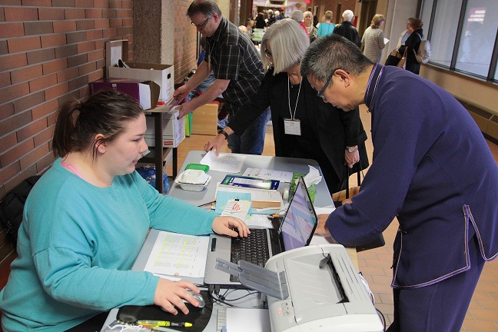
Check-in on Day One
Starting at 8 a.m. on Monday, April 30, go to the ELLA Registration and Information Tables located in the Education Centre, main-floor cafeteria hallway to pick up your name tag and course information. This includes those registered for Art Classes at Enterprise Square. The Information Table will be staffed through out Spring Session and it is the go-to location for information.

Food
Education Centre - Food and beverages can be purchased in the Cafeteria and at various other locations on (main) North campus. You are welcome to bring your own food and beverages and to use the tables in the cafeteria and the seating area across from N2-115 on the second floor.

Downtown at Enterprise Square – There are also places to purchase food and beverages in and near Enterprise Square, as well as student seating areas on the main floor and second floor for those who want to pack their own lunch.

Accommodations
St. Joseph’s College has a women's and a men's residence next door to the Education Centre and you may contact them at sjcres@ualberta.ca. Information on their Spring and Summer Residences is available at www.stjosephscollege.ca. ELLA does not arrange accommodation.

Scented Products
Some of our participants are sensitive to fragrances. Please refrain from wearing perfumes and other scented products.

Photos and Video Recordings at Spring Session
Volunteers will be taking photos and recording some sessions. These photos and recordings may be used for ELLA promotional purposes. If you do not want your photo taken, please inform the photographer and/or move out of the photograph or recording. Please note that in accordance with the University of Alberta Freedom of Information Guidelines, participating in ELLA programs is considered to be participation in a public event and as such the taking and use of photographs and videotapes by ELLA is not considered to be an unreasonable invasion of the personal privacy of the individuals photographed or recorded.

Noon Hour Presentations and Other Activities
ELLA’s Spring Session also includes Noon Hour Presentations, the ELLA Annual General Meeting and other activities. Please see pages 31 to 34. More details will be handed out when you pick up your name tag and course information on the first day.

Early Morning Classes – 9:00 to 10:10 a.m.
EL10 Paleontology
Instructed by: Eva Koppelhus, Philip Currie and various graduate students (MSc and PhD, as coordinated by Eva Koppelhus)
Vertebrate Paleontology is the study of extinct animals with backbones. It is a multidisciplinary science that relies on the support of many different disciplines, including vertebrate paleontologists and paleobotanists and a broad array of botanists, zoologist and geologists. In this course, you will learn about some of the exciting paleontological research being conducted at the University of Alberta. Covering everything from evolution of plants and early vertebrates, to feathered dinosaurs and the origin of birds, the course will show you how paleontologists work in the field and in the lab and squeeze not just anatomical information from fossils, but learn about evolution, ecology, physiology, behavior and so much more.
Dr. Eva B. Koppelhus is an Assistant Professor and Curator of the Paleobotanical Collections at the Dept. of Biological Sciences of the University of Alberta. Her research interest is now on floras of the Upper Cretaceous of northwestern North America. In June of 2011, she received the Stefansson Medal of the Explorers Club for outstanding contributions to paleontological field research in Canada.

Dr. Phil Currie recipient of the Alberta Order of Excellence Award is an internationally renowned paleontologist whose scientific accomplishments have led to a greater understanding of dinosaurs and their historic significance. He was instrumental in the development of Alberta's Royal Tyrrell Museum and has made major contributions to paleontology on both the Canadian and the world stage through his extensive field work, academic research, writing and teaching.

EL11 China and Her Neighbours
Instructed by: Gordon Houlden
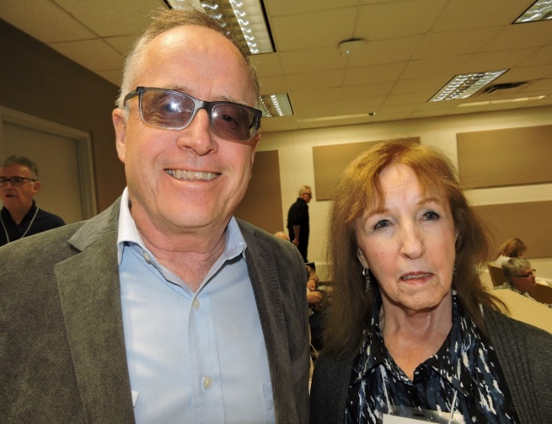
This course is a survey of the history, politics and culture of China, Japan, and the Korean Peninsula, including reference to Taiwan. The emphasis will be on the contemporary era. Shared characteristics between these Asian neighbours, as well as points of divergence will be highlighted. A couple of units will be taught by well-qualified guest lecturers, although Professor Houlden will deliver the great majority of the lectures. Current and high-profile issues related to East Asia will be examined.

Professor Houlden is Director of the China Institute (CIUA) and Professor of Political Science at the University of Alberta. While in the Canadian Foreign Service he spent 22 years working on Chinese affairs for the Government of Canada. Under Prof. Houlden’s leadership the CIUA focuses on contemporary China studies with an emphasis on Canada’s trade, investment and energy linkages with the PRC.
Professor Houlden with ELLA member Patti Osborn at Spring Session 2017.
EL12 Early Childhood Development: Everything Every Grandparent Should Know
Instructed by: Dr. Ruth Collins-Nakai

The course will cover the early years -- how an infant's brain develops and how young children learn, the effects of toxic stress, adverse childhood events, mental health and behavior, changing family structures, government policies, child care and early learning, economics of early child development, intercultural and indigenous approaches to child rearing, parenting, fetal alcohol spectrum disorder and trauma informed communities - all in language that lay people can understand! We will enlist a variety of specialized instructors from across the province in order that you understand how important early learning and childcare is to both your family and communities but also to the economy and future of our province and country. We will provide plenty of time for discussion and wonderful reference materials for in-depth additional information.

Dr. Ruth Collins-Nakai CM, MD, MBA, FRCPC, MACC. Cardiologist “Dr. Ruth” joined the Faculty of Medicine at U of Alberta in 1977, serving in various positions, including Professor of Pediatrics & Associate Dean. Recipient of many awards, including Member of the Order of Canada, she has worked at local, provincial, national & international levels in healthcare, education, research and philanthropy.

EL13 From King Porter Stomp to Kind of Blue: Jazz of the 1930’s, ‘40s and ‘50s
Instructed by: Dr. Michael Roeder
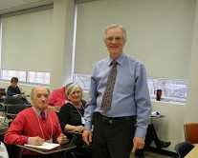
Dr. Michael Roeder
Jazz of the 1930s, ‘40s, and ‘50s is considered by many to be the Golden Age of Jazz. Through recorded music, we will explore jazz of these three decades and come to understand and appreciate the striking changes that took place during this time. The Swing era of the 1930s and early ‘40s was dominated by big bands, represented by those of Henderson, Goodman, Basie, and Ellington. The harmonically more complex Bop style of the late 1940s, forged by Gillespie and Parker, made use of a small combo. The Cool style of the 1950s (as in music by Davis, Modern Jazz Quartet, Getz, Mulligan, and Brubeck) often emphasized greater lyricism and more mellow sounds than did the Bop style. Hard Bop of the late 1950s embraced elements of the Bop style, often fused with traits associated with blues, gospel, and other strongly identified African American traditions. The 1959 album Kind of Blue by Miles Davis brought about another revolutionary change in jazz, leading to the development of Modal Jazz.

Dr. Michael Thomas Roeder has a passion and enthusiasm for both music and teaching. While teaching for over three decades at the U of A, Michael received several teaching awards including a 3M Teaching Fellowship, a national award for Canada’s finest university teachers. He has offered successful courses for ELLA since 2012. His book, A History of the Concerto, is the major study of the genre.

EL14 Jane Austen: Then and Now
Instructed by: Dr. Jared McGeough
2017 marked the 200th anniversary of the death of history’s most popular and enduring author, Jane Austen. What is it about Austen's life, characters, and style that continues to fascinate us today? This course will explore this question and others through discussions and analyses of Austen’s major novels, including Sense and Sensibility, Pride and Prejudice, and Emma, as well as provide students with an in-depth look at the historical, cultural, artistic, and political contexts that shaped Austen’s life and work. In an effort to better understand Austen’s marketability today, class sessions will be thematically split into “then” and “now.” “Then” sessions will focus on the novels themselves, along with their relevant contexts; “now” sessions will look at how Austen has been reimagined for contemporary audiences through different mediums such as film, comic books, web series, and literary parodies (Pride and Prejudice and Zombies; Sense and Sensibility and Sea Monsters). No prereading is required, but participants may wish to refresh their memory of Austen’s works.
Dr. Jared McGeough has taught British, Canadian, and Nineteenth-Century literature at Concordia University (Montreal), the University of Regina, and for ELLA. Dr. McGeough's current research explores ideas of 'parenthood' in Romantic and Victorian literature, including digitizing and annotating children's textbooks by nineteenth-century author William Godwin.

EL15 Linguistics: The Power of Language
Instructed by: Dr. Benjamin Tucker

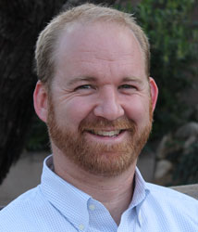
Language is a powerful part of our day-to-day lives. In this course we will learn and discuss many aspects of how we use language. We will first cover some basic concepts of linguistics such as the meaning of words (semantics), speech sounds and pronunciation (phonetics/phonology), the parts of words and how they go together (morphology), the sequencing of words (grammar/syntax). The instructor and guest instructors will use these concepts as a base to explore the sounds and writing systems of the world’s languages, the interaction of social issues and language, the psychology of language, creating languages, and the historical and familial relationship between languages. We will also discuss the tragedy of language death and endangerment and how communities and linguists are working on these topics.
Dr. Benjamin Tucker

Dr. Tucker is an Associate Professor in the Department of Linguistics at the University of Alberta specializing in phonetics. His research focuses on cognitive aspects of the production and perception of spontaneous speech (e.g., “Wazat?” for “What is that?”). He also works on the documentation of endangered and under-documented languages.

EL16 A People’s History of Canada
Instructed by: Alvin Finkel

The history of Canada looks very different when viewed from the perspectives of those at the bottom or even the middle of the social hierarchy than from the top down. Too often the history we learn in school is that of great white men (and a very few women) and their role in creating a “national identity” or putting “Canada on the world stage.”
What did any of that have to do with how ordinary people lived their lives, attempted to get by, and struggled to improve living conditions for people like themselves? This course focuses on the lives and struggles of working Canadians, Indigenous people, immigrants, visible minorities, women, sexual minorities and others whom a celebratory, “civics” framework, barely notices other than perhaps to acknowledge some particular milestone. Even then the history of struggle that produced that milestone is usually muted to make it appear that the nation’s leaders graciously made some concession unbidden to a lowly group of common Canadians.
Alvin Finkel is one of Canada's most prolific and best-known historians. His co-authored textbooks in pre-Confederation and post-Confederation history have been the most-used textbooks in Canadian history since 1993 and are now entering their seventh editions. His other 11 books include Social Policy and Practice in Canada: A History, and The Social Credit Phenomenon in Alberta.

EL17 Behind the Barn Door: Everything You Wanted to Know about Animal Agriculture
Instructed by: Dr. Frank Robinson

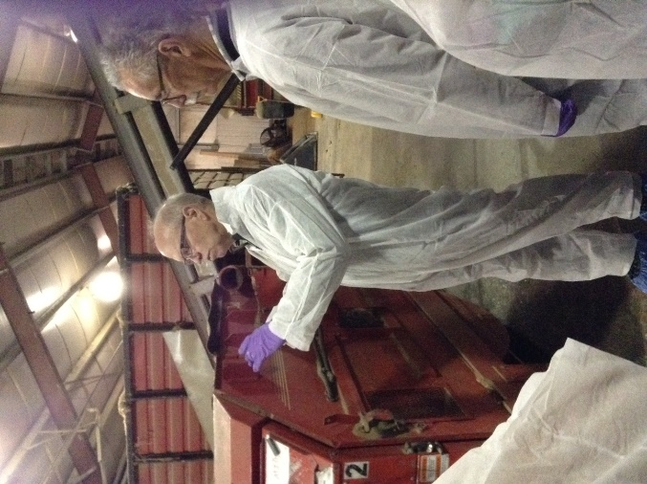
This class will be a lively lecture and discussion-based experience dealing with current issues around animal agriculture in Alberta. All food consumers will find it fascinating to learn how our meat, milk and eggs are produced and how farming has changed since we were young. Introductory topics will cover the changing demographics of farmer age, shrinking land bases and a growing global demand for protein. Technical material will only be presented when it is necessary to provide learners the tools to understand issues and form an opinion about them. Two field trips to the U of A South Campus Dairy and Poultry units will take place within the class period. Special topics to be discussed will include: genetic changes in farm animals, animal welfare, niche disease control, high-tech equipment and housing, back yard chickens, the use of steroid hormones in beef production, supply management, heritage breed conservation and much more. Students are encouraged to arrive at the class with questions they would like to learn the answers to during the course.
Dr. Robinson at the cow barn, Spring Session 2017.

Dr. Frank Robinson has been a professor at the University of Alberta since 1986. He has a BSc from the University of Saskatchewan, a MSc from Virginia Tech and a PhD from the University of Guelph. He has been active in research in poultry science. He was inducted into the Alberta Agriculture Hall of Fame in 2006, and is a 3M National Teaching Fellow.

EL18 Time Travel: The Victorian Era
Instructed by: Johanne Yakula

The Industrial Revolution affected every aspect of our Victorian ancestors' lives and set the stage for the way we live today. Time travel through the 19th century as we discuss culture, religion, sports, entertainment, inventions and technology and much more -- in short, the Victorian era. Be prepared to toss out romantic notions of how everything was much simpler then. Participants are encouraged to bring their own antique objects for discussion during each class.

Johanne Yakula is a graduate of the Alberta College of Art and Design, an interior decorator, and a certified antique appraiser. She shares her passionate interest in the history of life, art and design by teaching for the University of Alberta's Residential Interiors and Fine Arts certificate programs.

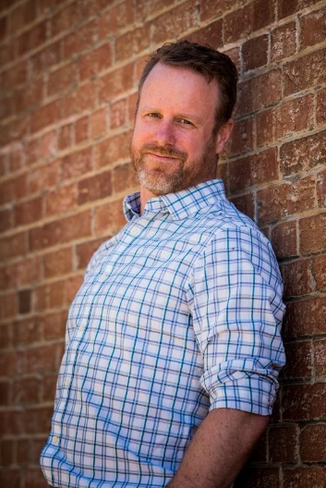
EL19 A Lifetime of Wellness
Reg Nugent
Instructed by: Reg Nugent

Gain an overview of the physical, social, psychological aspects of personal health and wellness within the context of healthy ageing. Lifestyle choices are introduced that affect personal health and the health of others. Learn how to take responsibility for your own health and to advocate for the health of others.

Reg Nugent (BSc, MA, Acupuncturist, Yoga) his scientific training (Psychology, Neurophysiology, Exercise Physiology and Endocrinology) along with his personal exploration into Eastern Healing (Arts of Aikido, Qigong, Reiki and Yoga). Reg specializes in realigning the physical body to decrease pain, improve performance and increase enjoyment of daily active living.

EL1A Mindfulness Meditation
Instructed by: Don E. Macdonald

Many spiritual traditions include meditation practices, to varying degrees. Buddhist Mindfulness meditation is the focus of this course and consists of lectures coupled with hands-on practice of various meditation styles, followed by discussion and reflective writing related to the meditation exercises. Lecture topics include eastern and western meditative practices, traditional Buddhist spiritual teachings, as well as recent scientific and neuroscience findings related to meditation. In the 21st century, mindfulness meditation is finding broad secular appeal in the west in diverse fields including education, psychology, and corporate wellness; all of these aspects are also explored in the course. Class capacity: 30.

Don Macdonald has a BSc (geology/religious studies) and a MSc degree, both from the University of Alberta. Don has been a practicing Buddhist for over 40 years and in 1995 he was ordained as a layperson Buddhist minister in the Japanese Jodo Shinshu tradition. Don has taught Mindfulness Meditation on Vancouver Island and with ELLA twice before. He currently lives in Sidney, B.C.

EL1X Tai Chi and Health QiGong Yi Jin Jing
Instructed by: Ken Chui
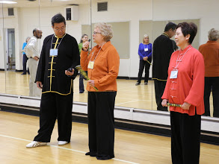
With its elegant, graceful and circular movements, this Simplified 30-form Wu Style Tai Chi course will allow students to relax and build harmony, co-ordination and balance in the body. During the first two weeks, classes will begin with a healthy Qigong warm-up for 20 minutes, followed by an opportunity to learn the new forms. The last week will involve practicing 20 forms or all 30 forms together. By then, students will have a basic understanding of Tai Chi and most will be able to complete the entire routine independently. The healthy Qigong Yi Jin Jing Warm up (also known as Tendon-muscle Strengthening Exercises) has been handed down from ancient China. By practicing these 12 routines, students will learn the foundation of Qigong. Extended, soft and even movements focus on turning and flexing the spine, thereby invigorating the limbs and internal organs. This helps to improve health and fitness, flexibility, balance and muscular strength. Class capacity: 30.
Ken with his teaching assistant (right) and an ELLA member at Spring Session.

Ken Chui is a certified instructor for Tai Chi and Qigong who taught for 10 years in Hong Kong before moving to Canada. Ken is also a registered and certified massage therapist in Hong Kong and Alberta. He believes proper posture leads to good health.

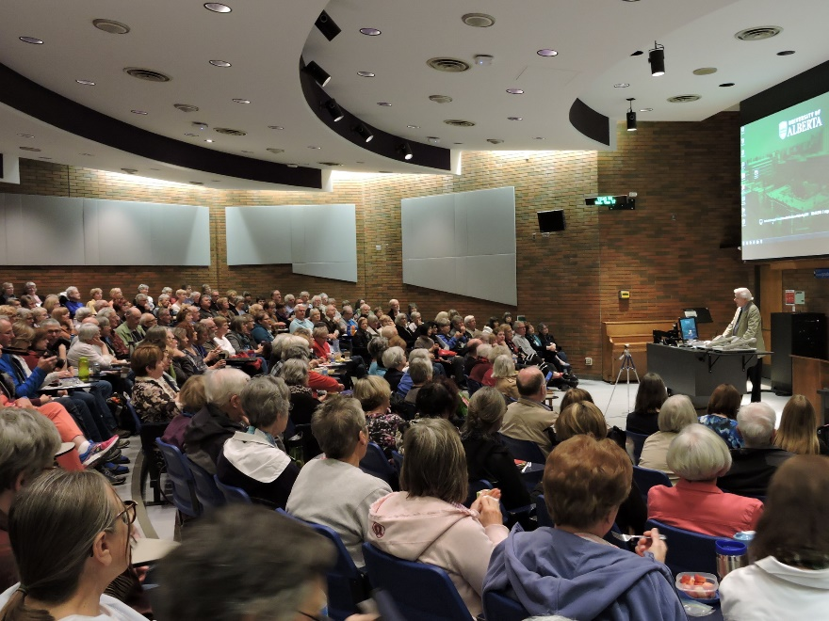

See page 33 for the list of Noon Hour Presentations.

Mid-Morning Classes – 10:25 to 11:35 a.m.

EL20 The ELLA Community Chorus
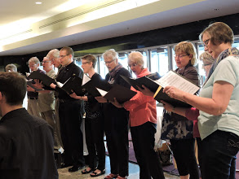
Instructed by: Dr. Evelyn M. Grieger
ELLA Community Chorus

This course will give participants the opportunity to come together as a microcosm of the entire ELLA community, and explore the joy and wonder of singing in a choir! As is the case for many community choirs, there is, of course, no audition – all are welcome. We will start with the basics of breathing and vocal production. Then we will work through all the elements of ensemble singing – choral breathing, listening, watching, facial expression, awareness, vowel formation, diction, etc. This will all come together as we sing through the chosen repertoire. Reading music will be as asset, but not required. We could close the ELLA 2018 session with a brief noon-hour concert on the last day.

Dr. Evelyn Grieger's vast conducting experience includes many choirs at a number of post-secondary institutions, as well as numerous community and church choirs. Dr. Grieger is the Minister of Music at First Baptist Church, and teaches undergraduate conducting at The King’s University. She also presents choral workshops with all kinds of choirs, and guest conducts in and around Edmonton and beyond.

EL21 The Canadian Charter of Rights and Freedoms: Simplified
Instructed by: Patricia Paradis

This course will familiarize students with the Canadian Charter of Rights and Freedoms by reviewing the developments that led to the inclusion of the Charter in the Constitution. It will explain the contents of the Charter and how it is used to protect and promote rights and freedoms, as well as how it relates to other rights legislation such as the Human Rights Act. The course will also show how the Charter intersects with our everyday lives through a review of seminal Charter cases covering several topics of interest such as: the right to physician assisted death, freedom of expression, freedom of religion and the new Quebec legislation banning face coverings in public places, legal rights such your rights upon arrest, and the right to be free from unreasonable search and seizure especially as it relates to digital devices, and remedies for Charter breaches in cases like the Khadr case.

Patricia Paradis, MEd, LLB, will instruct and coordinate a team of experts, primarily professors in the Faculty of Law to present this course. Patricia is the Executive Director of the Centre for Constitutional Studies at the University of Alberta. She is also a sessional lecturer in the Faculty of Law, having taught Human Rights Law in Canada for the past 18 years.

EL22 Physics is Life CANCELLED!
Instructed by: Vlad Pasek

Physics is omnipresent in our everyday life. This course aims to explain how. With a series of 15 themes, you will come to understand the physics of the everyday such as: what happens when you bring a charged object close to the narrow stream of a faucet? At what angle should you throw a basketball for it to easily enter the basket? What happens to a ball that is thrown in the air while you are driving and suddenly you stop? We will also explore: Why can’t planes fly when it is too hot? Why does your weight change on different planets? How trains are made to levitate so that they can travel at high speeds. Why did the Tacoma Narrows bridge collapse in Washington State? Why it is dangerous to keep playing golf when there is lightning. The use of nuclear energy (fission and fusion) for our use will be discussed. Every presentation will address different principles of physics illustrated by real life examples and enhanced with hands on experiments and multimedia.

Vlad Pasek began his career as a physics researcher at CMC & RCA and then moved on to teach physics with Edmonton Catholic Schools. He also lectured at the U of A. Academically, he earned a BSc, BEd and two MEd’s. He ran research projects on superconductors, holograms and cosmic rays. He was on the advisory panel for a physics textbook. He obtained the Hilroy Award and the Prime Minister's Award.

EL23 Skeleton Keys: An Introduction to Forensic Anthropology
Instructed by: Corinne Marceau and Alexandra Rocca

In this course, students will learn about the human skeleton and how to identify sex, age, trauma, and pathological conditions from the bones. Forensic applications such as determining time-since-death and cause of death will be discussed in the context of actual case studies from death investigations and historical cases, such as the Franklin Expedition. This course will attempt to dispel some of the misconceptions about forensic science that have been promoted in popular culture. Using the university's extensive osteology collection, students will work hands-on with human skeletal remains in a lab setting.
In order to participate fully in this class, students will need to meet at the osteology lab in the Tory Building on Saskatchewan Drive (approx. a 10-minute walk) for at least 3 of the classes.
Class Capacity: 25.

Corinne Marceau attained her MA in Anthropology at the U of A in 2007, specializing in Forensic Anthropology. She has completed an internship at the Medical Examiner's office and consulted on several forensic cases. She currently teaches Anthropology and Anatomy at Portage College and works in Transplant Services.

Alexandra Rocca is currently completing the second year of her Master's degree in biological anthropology on juvenile sex estimation at the University of Alberta. Her research interests are in both biological anthropology and forensic anthropology. She has worked with the forensic anthropologist of Northern Alberta on active cases as well as reviewed previous anthropological assessments.

EL24 A New Age: Painting and Sculpture from c. 1910 to c.1940
Instructed by: Kirk Marlow

The period just before World War I up to the outbreak of World War II was a time of significant and dynamic change in painting and sculpture. Within the space of 30 years, the development of abstract art challenged the long-standing realistic tradition of art. At the same time, or closely following, came such movements as Russian Avant-Garde art, Cubism, Italian Futurism, German Expressionism, Dadaism and Surrealism. The more conservative 1930s saw the rise of social expressionism, and the totalitarian art of some European countries that would soon go to war with each other.
With the use of visual images, Kirk Marlow will explore some of the art produced in these years and place it against the background of some historical and political events of the time.

Kirk Marlow, a native of Nova Scotia, received his degrees in English, Education and Art History at Mount Allison University in Sackville, New Brunswick, and Carleton University, Ottawa. In the 1990s he lived in London, England, working as an editor for Macmillan Publishing and Oxford University Press. From 1999 he has been an Art History Instructor at MacEwan University.
EL25 Nanotechnology: Some of the Biggest Ideas come from the Smallest Things
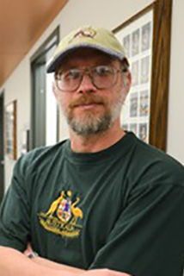
Instructed by: Dr. David Wishart
Dr. David Wishart

This course takes students on a journey through the field of nanotechnology. Nanotechnology involves the manipulation and characterization of tiny things – tiny being on the scale of 100 nanometers or less or about the size of 10 atoms, side-by-side. Nanotechnology holds considerable promise and billions of dollars have been invested into this rapidly growing field. Through nanotechnology it is possible to create many new materials and devices with a wide range of applications in medicine, electronics, energy and consumer products. Nanotechnology also brings some concerns, especially with regard to the environmental impact and toxicity of nanomaterials. This 15-lecture introductory course will provide a brief history of nanotechnology and a gentle introduction showing how nanomaterials are made and visualized. It will also describe a number of different nanotechnology applications with a special emphasis on showing how these new nanomaterials and nanodevices impact our daily lives.

Dr. David Wishart is a professor in the Departments of Biological Sciences and Computing Science at the University of Alberta. He has worked in many areas of nanotechnology for the last 20 years. He was one of the founding members of the National Research Council’s (NRC) National Institute for Nanotechnology (NINT) and served as the director of NINT’s Nanobiology Research Program from 2003-2017.

EL26 The Food We Eat: From Farm to Fork CANCELLED!!!
Instructed by: Dr. Laurie Drozdowski

A number of guest lecturers will be brought in to speak on topics related to the food we eat, including the production of food (agricultural practices/GMOs, sustainability, food processing, food/agricultural marketing) as well as the consumption of food (sensory qualities of foods, cultural meanings of food, food environments). Lecturers will be encouraged to make presentations interesting and interactive by using videos, demonstrations, and quizzes and by encouraging audience participation.

Dr. Laurie Drozdowski’s background is in nutrition research. She currently works as the Coordinator for the Centre for Health and Nutrition at the U of A. She has an MSc in Nutrition and Metabolism and a PhD in Experimental Medicine. While she has identified herself as the instructor, guest lecturers, all with graduate level education and expertise in their areas, will speak throughout the course.

EL27 The Art and Science of Nighttime Dreams
Instructed by: Dr. Jayne Gackenbach
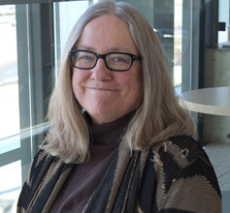
Dr. Jayne Gackenbach
This is a course about nighttime dreams. Following a brief examination of sleep, the science of dreams will be covered. Additionally, various dream interpretation approaches will be examined with both out-of-class and in-class activities.

Dr. Jayne Gackenbach, an Emeritus retiree from MacEwan University, has been doing research and teaching about dreams for 40 years. Her recent publications are on the effects of video game playing on sleep. She is a past-president of the International Association for the Study of Dreams. The highlight of her career was presenting her research into lucid dreaming to the Tibetan Dalai Lama at a meeting on Sleep, Dreaming and Dying.

EL28 And where are we? The Story of Maps
Instructed by: Danial Duda

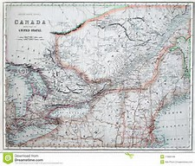
Maps are powerful and can ignite the imagination to run wild! In my career as a Map Librarian, people tell me how they look at maps and atlases and imagine travelling to enticing and exotic locales. This course will introduce you to the world of maps from many different perspectives: studying cultural viewpoints of European, Muslim, and Indigenous mapmakers, to name a few; examining historical documents from ancient times to the present day; using maps as political tools and propaganda; and seeing maps as knowledge repositories. We will also discuss the fundamental cartographic elements of scale, projection, and symbology. Maps, atlases, and digital images will be used to showcase this influential medium of communication through a combination of lectures and seminars. But map readers take note: as Monmonier writes in the introduction to his book: How to Lie with Maps, “Not only is it easy to lie with maps, it’s essential.”

Dan Duda began his map career in the Wonders Map Library at the University of Alberta in 1992. He completed his Library degree in 1999 at the U of A and his career took him to Memorial University in 2001 where in 2005 he became the Map Librarian. As Map Librarian, he’s been a guest lecturer about maps, cartography, and cartographic history for numerous courses and professional organizations.

EL29 Let’s Make Our Ethical Reasoning More Effective
Instructed by: Dr. Glenn Sinclair

This course is a combination of conversations, case studies, small group sessions, and the occasional lecture. The focus is on ethical reasoning (greater insight can be found on my web-site www.e-sinclair.com in the Research section – Kohlberg Through the Sinclair Prism – a paper entitled “Have We Got the Cart Before the Horse?”) enabling participants to access a tool to help them resolve the ethical dilemmas they face in their daily lives. This is not a course about right or wrong, good or bad, but rather, getting to better. Trying to understand the choices of your children or grandchildren? Wanting to effectively and consistently reason through the moment of critical choice yourself, so that the resolution is not only better, but others involved in the decision also improve their ability to get to better? This is all about practical and applied ethics, and the reasoning we need to employ to be effective in a practical and applied fashion at getting to better.

Dr. Glenn W. Sinclair holds a PhD (Ed Admin: Ethics and Leadership) U of Alberta along with an MA. (Education & Social Change) U of Minnesota plus an MEd (Curriculum Development) U of A. While leading his own firms, he has served as CEO for other organizations, taught more than forty years, presented at conferences, written papers, and chaired public inquiries seeking better solutions to critical choices.

EL2A Mathemagics and More
Instructed by: Len Bonifacio

We will explore many of the marvels of mathematics in number, geometry, algebra and probability. Amazing number patterns, proving the Pythagorean Theorem with water, constructing fractal stairs, and more, will be pursued. We will also explore two student-selected topics: First, Logarithms, with applications from earthquake intensity, wind strength and the spread of viruses to compound interest, temperature change, and depreciation. Then Quadratics will be addressed with applications from ballistics and sports to architecture, space travel and communication as well as medical and pharmaceutical applications.

Len Bonifacio is pleased to be back at ELLA for a 4th year. He spent over 40 years in math education mostly as a teacher, but also as a department head, district consultant, and provincial examiner. He is a contributing author to the high school texts used in western Canada and was a co-recipient of the MCATA Educator of the Year Award and twice a semi-finalist for a provincial Excellence in Teaching Award.

EL2X Body Realignment with Yoga and Exercise
Instructed by: Reg Nugent

Come learn what healthy alignment of our bodies is and how to get ourselves back to it. Some anatomy and physiology will be integrated into class to help us understand how our bodies are designed to move so that we can slow down any “Ageing” of our joints, muscles and spine. We will learn how to adapt the stretches and exercises to where we are now, to help us get where we want to go! Participants will need to be able to get down and up from the floor at least three times per class. Please bring your own yoga mat.
Class capacity: 30.

Reg Nugent (BSc, MA, Acupuncturist, Yoga). Reg combines his scientific training (Psychology, Neurophysiology, Exercise Physiology and Endocrinology) along with his personal exploration into Eastern Healing (Arts of Aikido, Qigong, Reiki and Yoga). He specializes in realigning the physical body to decrease pain, improve performance and increase enjoyment of daily active living.

All Morning Classes – 9:00 to 11:35 a.m.

EL30 Exploring the Landscape in Watercolour (Intermediate – Not suitable for beginners)
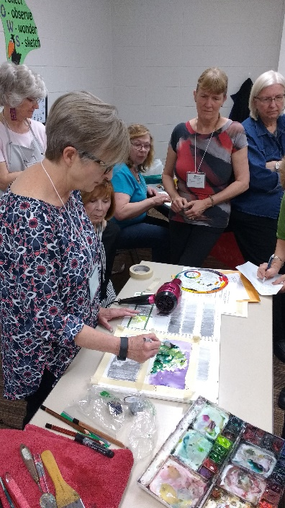
Instructed by: Frances Alty-Arscott

This course is designed for those individuals who have already mastered the basics of working in watercolour. Students will learn to enhance the freshness in their work by experimenting with new ideas and alternative painting techniques. There will be demonstration and class discussion, but students will be encouraged to explore their own personal direction through individualized instruction. Basic mastery in the watercolour medium is required for this course. This class is downtown at Enterprise Square (10230 Jasper Avenue). Check the ELLA website or contact the ELLA office for a supply list.
Class capacity: 20.
Frances Alty-Arscott, BFA, is a well-known Alberta Artist who resides in Edmonton. Her work can be found in many private and public collections in Canada and in the United States. Frances is represented in several galleries in Alberta. In Edmonton her work can be seen at Rowles and Company Gallery. More of Frances’ art can be seen on her web page at: www.altyarscott.net
Frances at Spring Session 2017.

EL31 The Science of Acrylics (Experienced beginner to intermediate in acrylics)
Instructed by: Samantha Williams-Chapelsky and Rick Rogers

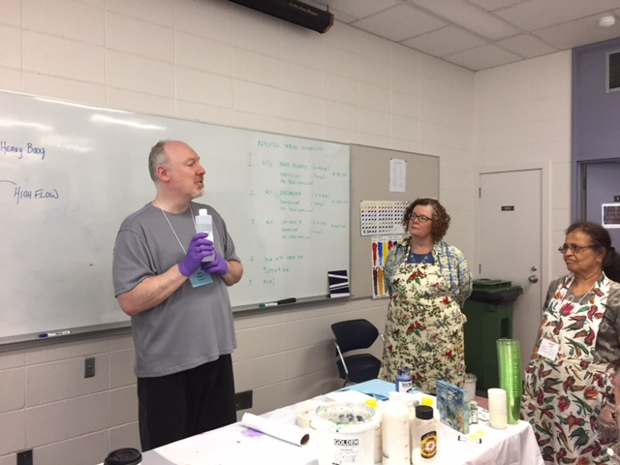
In this course, you will first experiment with scientific principles and properties of acrylic media; then you will apply what you have learned in the context of creating art. Classes will alternate, within each project, between experimentation and creation. The projects will alternate between the two instructors. Expect to explore the principles underlying effective design patterns for fine art, the biology and physics behind your perception of colour and depth, and the physical and chemical properties of acrylic media. Experience in Acrylics is required for this course. Check the ELLA website or contact the ELLA office for a supply list. This class is downtown at Enterprise Square (10230 Jasper Avenue). Class capacity: 20.
Rick Rogers at Spring Session 2017.

Samantha Williams-Chapelsky is a BFA graduate from the University of Alberta with an extensive exhibition list. She is also the Golden Working Artist for the province of Alberta.
Rick Rogers is an acrylic artist practicing in the province of Alberta with an impressive exhibition record. He is known for his scientific approach to acrylic paint as well as his knowledge of the medium.

EL32 Learn to Carve Wood: Carving a Wood Spirit
Instructed by: Laurie Wilson-Larson

You will create a Wood Spirit in Cottonwood bark. Wood Spirits are realistic human faces that are carved in bark and look like an expression of the spirit of the tree from which the bark grew. Throughout the course you will learn how to use and care for your tools and learn basic cuts as you progress toward making a Wood Spirit. You will practice cutting skills as you carve a “story stick” that breaks down the steps in carving facial features and will take this home for reference. As you create your piece, you will learn to layout the features of the face, learn how to carve facial features onto your piece and how to finish the piece to create a lasting work of art. This course would be suitable for never-carved-before beginners, as well as advanced students. More advanced students will plan for and carve deeper into the bark, creating details that add interest to their pieces. You may also be able to create multiple faces on your piece(s). Check the ELLA website or contact the ELLA office for a supply list. Class capacity: 20.

Laurie Wilson-Larson is an award-winning wood carver who has specialized in carving human faces. At Lee Valley Tools, St Albert Seniors Association and with ELLA, she has instructed individuals of all skill levels to carve Wood Spirits, facial features, caricatures, and carving faces in a golf ball. As a recreation therapist she has proven skills teaching elders and individuals with special needs.

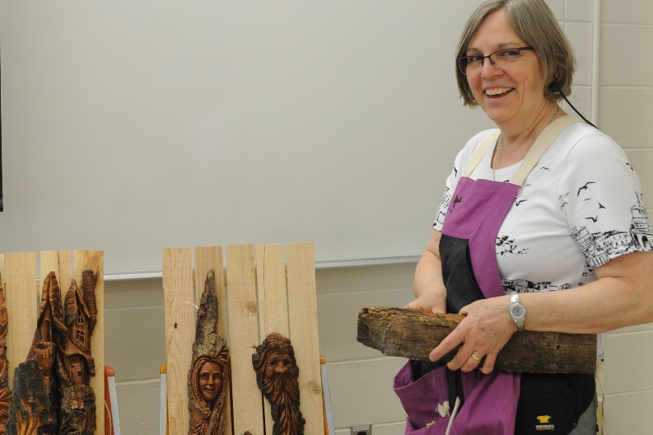
Laurie at Spring Session 2017.
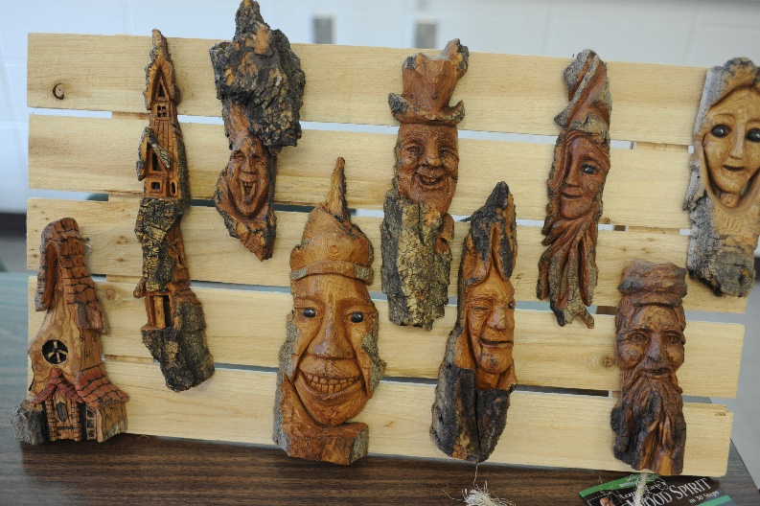
Wood spirits created by ELLA members at Spring Session 2017.

Early Afternoon Classes – 1:15 to 2:25 p.m.

EL40 A Brief History of Asian Art
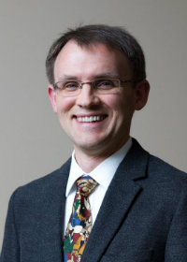
Instructed by: Dr.Walter Davis
Dr. Walter Davis

This course offers a selective, chronological introduction to the visual arts of Asia. Slide-illustrated lectures will characterize historical developments in the visual arts of India, China, and Japan from Neolithic times through the early modern era. Analysis of sculpture, painting, ceramics, and other art forms will call attention to their formal properties and to their social, economic, political, religious, and philosophical dimensions. Please note that this is a course in art history, not art instruction.

Dr. Walter Davis is Associate Professor of East Asian Art History at the University of Alberta, where he teaches in the Department of Art and Design and Department of East Asian Studies. Although broadly trained in the art histories of South and East Asia, Professor Davis focuses his research on China and Japan’s early modern and modern visual arts, especially their historical intertwining.

EL41 Evolution and Extinction of Life of Earth
Instructed by: Don Macdonald
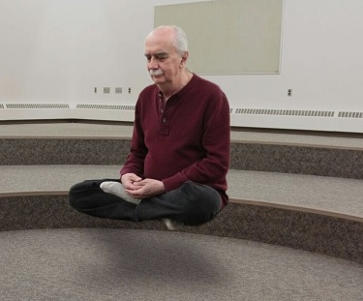
Don in his other teaching role at Spring Session.
This course will outline how life arose on Earth nearly 3.8 billion years ago and describe its subsequent evolutionary blossoming over geological time. In particular, we will focus on how global mass extinction events severely knocked life back and thereby altered the trajectory of biological evolution. We will document how over the past 20,000 years humans instigated a major large mammalian faunal extinction. Finally, we will examine how in the past 100 years or so, humans have set-off another major extinction event that is impacting a large number of species, and how this again, is changing the course of biological evolution on Earth.

Don Macdonald has a BSc and MSc from the University of Alberta in earth sciences with a minor in religious studies. He has worked as a research geoscientist, an R&D manager, an environmental/climate change and energy policy advisor, and an educator at MacEwan University and the U of A. As a practicing Buddhist for over 40 years, Don also teaches mindfulness meditation.

EL42 Plastics: A Blessing and a Curse
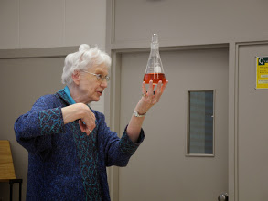
Instructed by: Dr. Margaret-Ann Armour

Plastics are all around us. It is hard to imagine life without them. Since the discovery of Bakelite in 1907, the variety and quantity of plastics, or more correctly, synthetic polymeric materials, has mushroomed. For example, they are used in clothing, building materials, packaging, and transportation vehicles from cars to aircraft. They have brought many benefits to our society, including in the fields of safety and health. However, when plastics are discarded, they do not readily decompose and are now causing environmental pollution, both on land and in the oceans. In this course, we will look at what these polymeric materials are, how they are made, why they are so durable and at a variety of their applications. We will then explore the effect of waste plastics on us, on wildlife and on the planet, discuss how we can mitigate the pollution that has already occurred, and share the methods being used to reduce and hopefully eliminate plastic trash in the future.
Dr. Armour in action at an earlier Spring Session.

Dr. Margaret-Ann Armour has degrees from the Universities of Edinburgh and Alberta. She joined the Chemistry Department at U of A doing research on chemical waste and is now an Associate Dean of Science. Through WISEST, she encourages women into the sciences and enjoys visiting the Edmonton school that bears her name. Her awards include the Order of Canada and 6 honorary degrees.

EL43 All Things Music
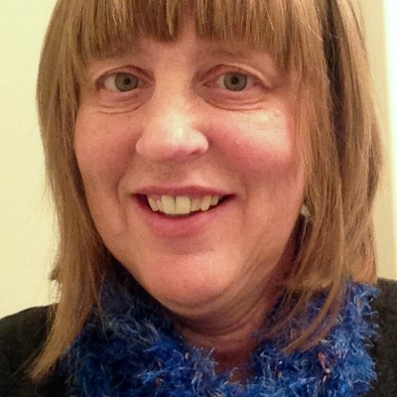
Instructed by: Rebecca Schellenberg

Hold on to your hats! Get ready for a madcap caper through a wide range of musical topics. We will tackle Rush to Rachmaninoff, Canadian fiddle music to Beethoven’s Kreutzer sonata. Listen to obscure Cuban music, try your hand at free form music analysis. Discover some of our own Edmonton composers, and listen to Viotti’s little known works. Every class promises to be both fun and inspiring! We’ll address questions like how can you make sense out of a symphony? What is perfect pitch? And what is the deal with Stradivarius? You won’t want to miss the class about music that tickles your funny bone! There may even be a live musical demonstration or two, with some of Edmonton’s finest composers and musicians. You will have an increased awareness of the vast variety of music that is just waiting to be experienced. This course is for the hardcore music lover, the music novice, or for anyone who wants to learn more about all things music!
Rebecca Schellenberg
Rebecca Schellenberg is a violinist, teacher and writer. She has performed with various symphonies including Edmonton Symphony, Regina and Prince George symphonies. She continues to play in ensembles, adjudicates and teaches privately. Rebecca has a Master of Music degree from the U of A, and a Bachelor of Music from Brandon University.

EL44 The Blank Page: Writing for the Health of It
This is an all-afternoon class. Please see page 29 for the description and instructor bio.

EL45 Other-Worldly Journeys: A History of the Occult
Instructed by: Dr. L. Bruce Miller

Throughout history human beings have experienced dreams, waking reveries, and trances in which the question is asked, where does the soul go in travelling into the beyond? This course is a short history of otherworldly journeys: the ecstatic journeys of shamans; otherworldly journeys in ancient Mesopotamia, Egypt and Greece; Jewish and Christian apocalyptic journeys; Gnostic otherworldly journeys; the interplanetary tours of Renaissance magicians (astral magi, kabbalah and alchemy); and the "explosion" of the occult and the esoteric in our modern, secular age. Questions abound: Do the occurrences of out of the body experiences and near-death experiences suggest the possibility of journeys into a fourth dimension? Do recent scientific and cosmological speculations about parallel universes and the multiverse make otherworldly journeys more plausible?

Dr. Bruce Miller has a PhD in Religious Studies from the University of Chicago. As a Fellow of the Jesus Seminar, a United Church Minister and a former MLA for Edmonton-Glenora, he is a popular lecturer on Comparative Religion, Christian Origins, and the history of the Occult.

EL46 Literature and the Real World: How Our Cultural Identities Evolve After Immigration
Instructed by: Dr. Regan Treewater-Lipes

The central goal of this class is the exploration of what comprises multifaceted identity as demonstrated in contemporary world literature. As globalization continues to facilitate cultural diversification, the themes and characters portrayed within fictional narratives have likewise begun to reflect a unique phenomenon termed ‘cultural multilayering’. The multilayered cultural identity is the result of a mosaic of external influences resulting in the formation of new non-homogenized cultural selves. This is predominantly the outcome of immigration (both voluntary and not). By understanding cultural multilayering, one is able to gain valuable insights into a very current and relevant global trans-cultural/trans-national trend. Within the cultural melting pot of Canada, literature composed by immigrants is plentiful and rich. Authors like Bezmozgis, Badami and Thuy add a dimension to contemporary Canadian literature epitomizing the cultural multilayering brought about by immigration.

Dr. Regan Treewater-Lipes holds a PhD in Comparative Literature from the University of Alberta. Her research deals primarily with transnational identity studies, Jewish cultural memory, Russian émigré literature and nostalgia. She currently teaches at MacEwan University in the Department of English.

EL47 Contemporary Africa: Society and Politics
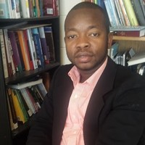
Instructed by: Dr. Isaac Odoom
Dr. Isaac Odoom

In this course, we will explore the society and politics of contemporary West Africa with an objective of portraying its complex social, economic, cultural and political picture and to challenge simplified generalizations and stereotypes about the region. First, we examine the image, myth and stereotypes of Africa in the western media and popular culture. We will aim at challenging ‘the single story of Africa’ by showing the rich, vibrant and bustling aspects of Africa that are often missing in the global media.
The second part of the course briefly examines the historical, economic and political backgrounds of West African countries. The third part of the course familiarizes students with the daily realities, opportunities and challenges of West Africans in the present dispensation. Alongside this thematic focus, the course will also emphasize more in-depth historical analysis through detailed case studies of several west African states, including Ghana and Nigeria.

Dr. Isaac Odoom recently completed his doctoral degree in Political Science/International Relations at the University of Alberta. His scholarly interests include Africa’s international relations, political economy of development, Africa-China relations and foreign policy of rising powers. He has published on topics such as development, international relations, and politics in Africa.

EL48 The Immune System: A Fighting Machine
Instructed by: Dr. Shairaz Baksh

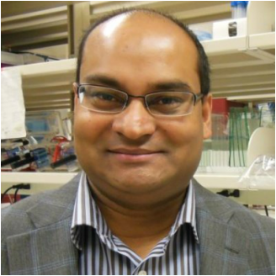
The course content will focus on the origin and function of the immune system. The immune system is our first line of defense against pathogens, chemicals and internal tissue damage. It provides a rapid response to the initial insult, a mechanism for repairing the damage and for clearing the insult. If not properly controlled, it can drive the appearance of disorders such as diabetes, obesity, Parkinson’s disease and cancer. We are beginning to understand how inflammation influences these diseases, how it remembers a prior exposure to a pathogen or chemical and we are advancing in designing therapeutics to correct and treat abnormal inflammatory conditions. We will focus on the application of our knowledge of the immune system to better understand our daily activities. The instruction for this course will be at the level of grade 12/first year of undergraduate university
Dr. Shairaz Baksh

Dr. Shairaz Baksh is an Associate Professor at the University of Alberta. He has a BSc (Biochemistry, University of Alberta), PhD (Pediatrics, University of Alberta) and post-doctoral training at Harvard Medical School and at Cancer Research UK. He has been on faculty at the University of Alberta since 2005 where he has explored the molecular and genetic control of inflammation.

EL49 Religious Extremism – Ideology, Motivations, and Consequences
Instructed by: Dr. Maryam Razavy
The intersection between religion and violence is not a new phenomenon--in fact, they have been closely associated throughout much of human history. This relationship between religion and violence in society elicits a host of questions including: Where does religious violence stem from? What exactly is the relationship between faith and belief? What motivates extremists, and extremist views? Using a number of historic and contemporary case studies this beginner level course will examine the relationship between religion and violence, with a particular emphasis on the ways in which scholars aim to explain such violence beyond a simple act of belief. Course format will generally be lecture accompanied by power point slides, and seminar-style discussion. No previous knowledge of religious belief systems is necessary for this class. Note: We will be viewing numerous segments of films and video documentaries in this class.
Dr. Maryam Razavy holds an MA in Religious Studies and a joint PhD in Sociology and Religious Studies from the University of Alberta. She lectures primarily in the area of contemporary Islam, religion and violence, and sectarian groups and violence. Her current areas of research include religious/cultural health and healing.

EL4A Progressive Core Stability
Instructed by: Barb Turner

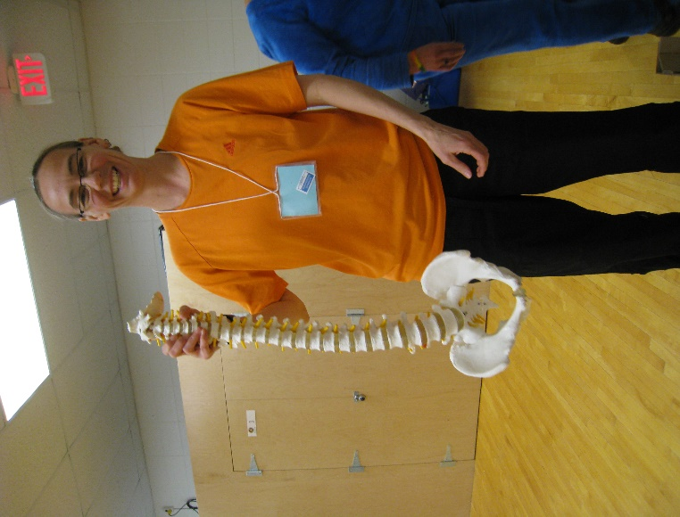
This class will give the participant the opportunity to build core strength in a safe, progressive fashion. The basic concepts can be built into activities of daily living and be used anywhere. The participant will also be able to gauge their own progress through body posture checks. Physiological and movement concepts will be covered in the classroom and will then be put to practice in the fitness studio through progressive exercises including spinal stabilization, core strength, hip function/health, postural alignment and balance. The exercises are a combination of yoga, martial arts, Pilates, cross fit training and sport specific training. Participants must be able to get on the floor to do some of the exercises.
Class capacity: 20.
Barb Turner is certified with the Canadian Society of Exercise Physiology as a Personal Trainer with more than 25 years’ experience, and with the AFLCA with Older & Portable equipment. She has a U of A degree in Injury Assessment, Injury Rehab, and Exercise Prescription. Currently she is employed as a Kinesiologist with Alberta Health Services and as a contractor and guest lecturer with CLSA and U of A for exercise instruction. Core stabilization is her specialty. She is a retired professional basketball player.
Barb Turner at Spring Session 2017.

EL4X Line Dancing
Instructed by: Dwayne Tulik

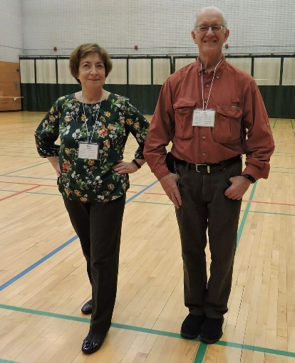
Dancing strengthens muscles, improves balance and flexibility while remembering steps, aids memory. Come and join us having fun kicking up your heels to lively music, while toning your muscles, stimulating your brain and strengthening your heart. In this class we will learn the basic steps to a variety of popular traditional and new line dances. This class is to be held in the East Gym of the Van Vliet Complex (about 5 minutes’ walk from the Education building) Street shoes are not permitted in the gym. Bring clean indoor athletic shoes or dance shoes. Participants must be able stand for 70 minutes, move forward and back and side to side.
ELLA members line dancing at Spring Session 2017.
Class capacity: 50.

Dwayne Tulik, Professional Dance Instructor, has been teaching and judging dance since 1982 throughout Alberta. He has been working with the City of Edmonton and various senior's centres over the years teaching Country and Western Dance. Dwayne's teaching skill and enthusiasm for dancing will have participants moving confidently across the dance floor.

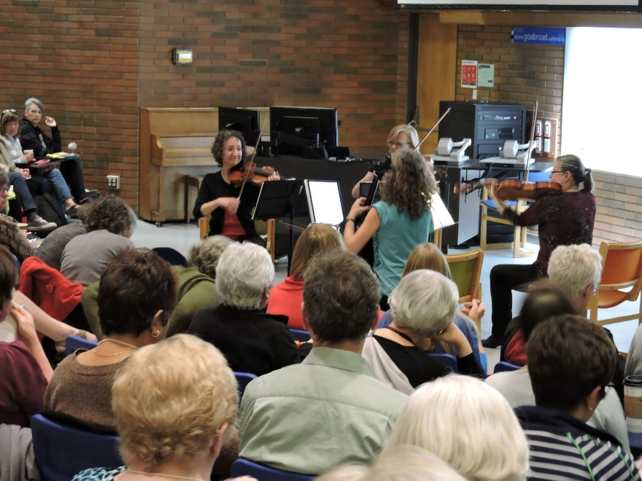
‘

Enjoy the Strathcona String Quartet during the opening day noon hour in Education N2-115.

Mid-Afternoon Classes – 2:40 to 3:50 p.m.
EL50 Conversational Geology: Topics of General Interest
Instructed by: Brian Sawyer

What causes earthquakes, volcanoes and tsunamis? Why are there so many kinds of rocks and minerals? How did Alberta's Rockies, Foothills and Plains get here? Is it true there was once an ice sheet one km thick where I am standing now? How do we know? The Earth provides us safe haven, nourishment, a wealth of natural resources and the occasional catastrophe. The goal of this course is to develop a basic understanding of the Earth as a 'living' planet, where plate tectonics generate volcanoes and mountains. Oceans play a key role in controlling climate; water and ice turn mountain ranges into sand. Science is still discovering the secrets of the sea floor -- where life may have started. Rivers and beaches are constantly changing, despite our efforts to tame them. The human-interest components of these topics usually generate conversations, and we'll leave plenty of time for those.

Brian Sawyer was first interested in physical landscapes as an artist and illustrator (BFA Visual Arts, U of Victoria) and later as a geomorphologist (MSc, U of Alberta). A senior manager in Alberta Environment, Brian has taught a dozen introductory courses at the University of Alberta and local colleges on the topics of Earth Science, Geographical Information Systems and Remote Sensing

EL51 Conservation in Alberta: Land, Water and Wildlife
Instructed by: Dr. Kecia Kerr

This course will provide students with a comprehensive understanding of conservation in Alberta – from a historical perspective on the importance of protecting wilderness and endangered species, to a practical understanding of an individual’s local impact. In Week 1, students will learn about conservation on a landscape scale, including the establishment of our protected areas system, land use and conservation issues in Alberta, and a review of international conservation standards. Week 2 will focus on specific issues in Alberta, from the boreal forest to headwaters to grizzly bears and caribou. In Week 3, students will learn about conservation in action: on-the-ground efforts being made in the province, including collaborative conservation efforts such as the Canadian Boreal Forest Agreement, Alberta’s Climate Leadership Strategy, and the Love Your Headwaters campaign, as well as how individuals can take action by zooming in on local issues, such as pesticide use or waste reduction.
Dr. Kecia Kerr

Dr. Kecia Kerr is an ecologist with a background in research and education. She has conducted research in Canada, the USA, Latin America, and Australia. She took on the role of Executive Director of CPAWS Northern Alberta in June 2017.

EL52 History, Culture and People of the East African Coast
Instructed by: Dr. Christine Mhina

This course is an overview of the cultural, social and political history of the East Africa region, which includes the countries of Kenya, Tanzania, and Uganda. The course is divided into three sections. The first section of the course will focus on the geographic, historical and political aspects of East Africa. Learners will engage relevant scholarship concerning the historical and social construction of East Africa. Although we will begin with early history, more time will be spent on the past 200 years. The presentations will touch on slavery, its abolition, the great scramble, and partition of Africa, colonialism in Africa, the de-colonization struggle and the rise of African nationalism.

Dr. Christine Hellen Mhina obtained her PhD in International Intercultural Studies at the University of Alberta. Over the years of her work experience as Agricultural Extension Officer in Tanzania she developed expertise for working with ordinary people in rural communities and learned the value of including diverse perspectives for community action and social change.

EL53 Engineering Through History: An Appreciation
Instructed by: Bob Rose

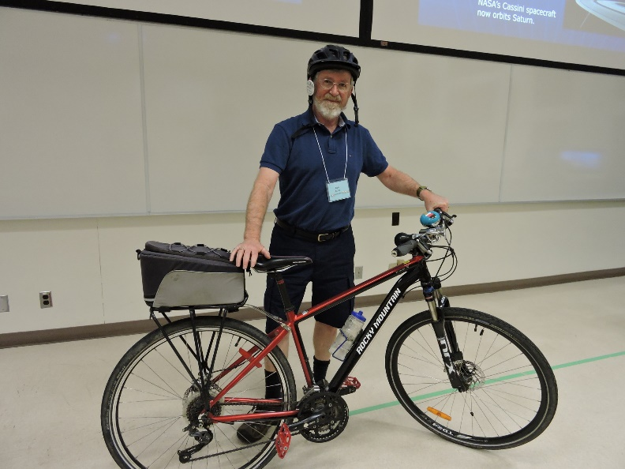
For thousands of years, engineers applied their knowledge of science and mathematics to benefit civilization. This course will provide non-technical students with a general understanding of the role of engineers in our world. From ancient eras to today, the course will follow the historical development of technology and its benefits to society. Specific engineers in history and their achievements will be discussed. The course will give a whirligig tour of the types of engineers (civil, mechanical, electrical, chemical, etc.), and their contributions. 21st century achievements such as biomedical, computer, and materials engineering will also be covered. When appropriate, specific Edmonton engineering accomplishments will be discussed. Topics such as Edmonton’s first bridges, railways, street cars, telephones, water, and power systems will be revealed. This course is up-to-date with new information from the instructor’s recent visits to historical sites and museums in Europe
Bob Rose at Spring Session 2017.

Bob Rose is an electrical engineer and graduate of the U of A. He worked 35 years in Alberta’s electric power industry. In the last 15 years he gave over 200 volunteer science presentations in Edmonton schools. He has also been a speaker at over a dozen Alberta science teacher conferences. In 2009 he was awarded a fellowship by Engineers Canada for his lifetime contribution to the profession.

EL54 Basic Digital Photography
Instructed by: Chris Stambaugh
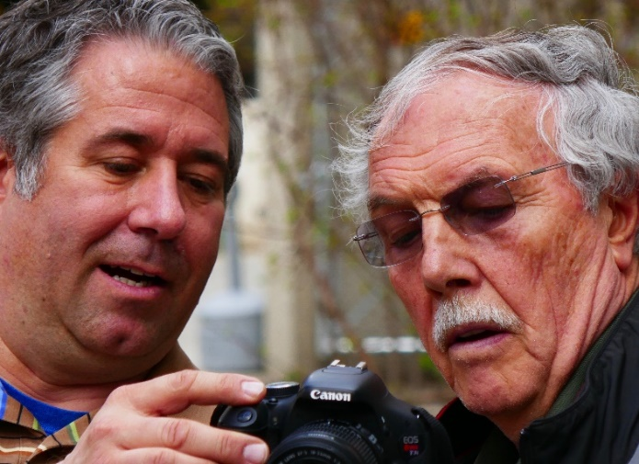
This class is designed for the beginner to intermediate level photographer. We combine instruction, demonstration and hands-on practice to teach you how to achieve the best technical quality images. The aspects of exposure, color and sharpness are emphasized while also exploring various other features of your camera. Detailed discussions on the elements of composition round out the program to explore the artistic side of photography as well. All camera types are welcome; however, some basic point and shoot models may not have all the features discussed. All students will gain a better understanding of their camera and be able to compose more interesting photographs.
Chris (left) with ELLA member at Spring Session 2017.
Class capacity: 30.

Chris Stambaugh graduated from the NAIT photography program in 1989 and opened his business in 1990. He has served as president of the Alberta Professional Photographers and the Professional Photographers of Canada. He holds the Master of Photographic Arts designation and has won numerous awards. Chris currently teaches classes at The Burwell School of Photography and NAIT Continuing Education.

EL55 Finding My Place: A Journey from Truth to Reconciliation
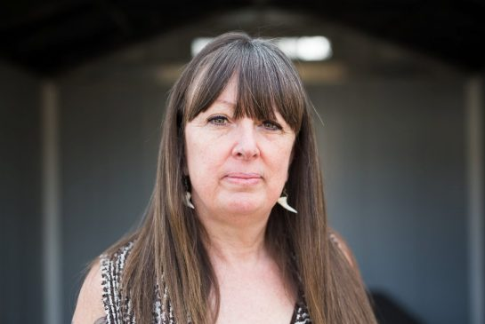
Instructed by: Charlene Bearhead
Charlene Bearhead

This course will examine the reality of the Indian Residential School system in Canada, the Indian Residential School Settlement Agreement and the truth of our collective history through this period of time in our country. Students will be engaged in the exploration of contemporary issues arising from this system and colonization more broadly in considering the prevalence of Indigenous children in the foster care system, missing and murdered Indigenous women and girls, incarceration of Indigenous peoples, current levels of racism and ignorance in the non-Indigenous population etc. The course will move to engaging students in reflecting on their own individual and collective roles in reconciliation and commitments to action based on the Truth and Reconciliation Commission of Canada's 94 Calls to Action released in June 2015. Course material will be delivered through oral presentation and testimony, film and video, online content and reflection on readings.
Charlene Bearhead currently serves as the Education Coordinator for the National Inquiry into Murdered and Missing Indigenous Women as well as supporting the Alberta School Boards Association and the College of Alberta School Superintendents: Education for Reconciliation. Charlene most recently served as the first Education Lead for the National Centre for Truth and Reconciliation at the University of Manitoba.

EL56 Experiencing Solo Travel: Strategies for Success
Instructed by: Dr. Pamela Young

Do you have a long bucket list of travel destinations, but a short list of travel companions? Have you considered hitting the road alone, but find yourself hesitant to make solo travel plans? This course will help you say “I’m on my way!” to those destinations that are calling your name. We'll address common concerns of solo travelers: knowing what information sources to trust when you research your destination; finding accommodations where you’ll feel welcome and secure; establishing safe and enjoyable connections with others on the road; making mealtime on your own a pleasurable experience; and dealing with the naysayers in your life who try to hold you back. During the course, you'll build a personal menu of solo travel strategies, facilitated by instructor tips and tricks, discussion, writing, drawing, personal research, and optional but recommended "homework" at Edmonton and area travel destinations.

Dr. Pamela Young is a seasoned solo traveler, blogger, and owner of Wise Woman Travel, a consulting company that assists women to travel on their own. She is the academic team lead of a Faculty of Extension program that assists international professors to teach their courses using English. Pamela holds a Ph.D. in Education, and has more than 20 years of adult education experience.

EL57 The Story of Modern Fashion: 1789 to Present
Instructed by: Julia Petrov

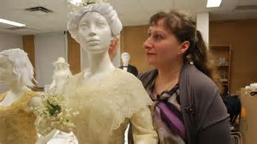
This course provides an introduction to historical of dress across genders and ages from the French Revolution to today. Students will learn how clothing styles and fashion periods related to socio-cultural phenomena in the modern world. Literary, visual, historical, and artefactual material will be presented as potential sources of study for information. Seminar-style lectures will analyze themes such as: beauty, art and fashion, production, photography and illustration, the designer, the movies, home sewing, useful inventions, consumption, ethics and luxury branding. The course will also include at least one field trip to the Human Ecology Department’s Clothing and Textile Collection approximately 10 minutes’ walk from the Education building on campus.
Julia Petrov

Julia Petrov is Curator of Western Canadian History at the Royal Alberta Museum and Adjunct Academic Staff at the University of Alberta. She has taught and published on dress history since 2004.

EL58 A Continuing Look at the Dark Side of Fine Art: Rogues Gallery II
Instructed by: Hoyne Santa-Balazs

The radiance of great art can mask dark shadows, where duplicitous characters traffic in transcendent beauty. This course is a continuing exploration of the colorful, sometimes comical, occasionally heartbreaking history of art crime in recent times. Art crime has a peculiar place in the spectrum of malfeasance. Museums and collectors often look the other way. Shady and eccentric characters hide behind masks of aesthetic appreciation. Before their fall from grace, some were respected curators, dealers, and experts, but they bet their reputations for the hope of winning even more. Some notorious cases made international news, but there are some equally outrageous ones the general public might never hear about. This course has no prerequisite and previous attendance in Rogues Gallery 1 is not necessary, but if you attended the previous course, then Rogues Gallery II will reveal new developments in cases you already know, and unveil more cases of the stealing and concealing behind art dealing.

Hoyne Santa-Balazs teaches art history at the U of A and at MacEwan University. She has taught a variety of topics from prehistoric to contemporary art. Her area of interest is cultural property, art and the law, art crime, illegal trafficking, and the protection of art in conflict zones. Hoyne has been a recipient of distinguished teaching awards from both the University of Alberta and MacEwan University.

EL5X Gentle Yoga for Strength, Relaxation and Health
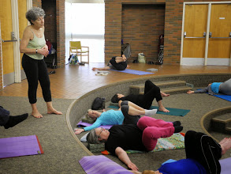
Instructed by Anita Sielecki
Anita teaching at Spring Session.

The intention of this course is to offer a time to calm down, reconnect with the body and restore your energy. It is not necessary to have a flexible body in order to participate. The class should be suitable and beneficial to participants new to yoga and to more experienced practitioners willing to slow down somewhat and experiment with a more meditative approach. The tools to be explored include simple breathing exercises to bring awareness to the body, calm the nervous system and slow down the thinking process and introductory yoga movements to free the joints, gently stretch the muscles, help develop more strength, balance and flexibility while facilitating the relaxation of the physical body. The pace will be progressive and the participants will be encouraged to move within their capacity, noticing and respecting how the body feels in each moment. A few minutes of guided relaxation will close each session to give the mind an opportunity to settle down and refresh. Please bring your own yoga mat. Class Capacity: 35.

Dr. Anita Sielecki has practised yoga since 1974. Certified as a yoga instructor in 1990, she taught for Campus Recreation since 1993. She worked in Biochemistry research at the U of A from 1976 to 1996 when she left her career in science to dedicate her time to the teaching of yoga, presiding over The Yoga Association of Alberta for 10 continuous years and organizing numerous yoga/meditation retreats throughout the province.

All Afternoon Classes – 1:15 to 3:50 p.m.

EL44 The Blank Page: Writing for the Health of It
Instructed by: Eunice Scarfe

This workshop is designed to experience the health that comes from choosing to enter into creativity through the act and art of writing. How do we work in this class? The same steps are taken every day: you listen to a published excerpt which illustrates a writing technique; you write for at least twenty minutes; you are invited to read aloud from your words (always optional!) When you read aloud, you will hear what is right with your writing. You will receive a supportive response, designed to lead you back to your writing.
In this method, you choose your own subject and form; whether to write for your eyes alone or for possible publication; whether to continue a project or to begin something new. The method is suitable for everyone. If you have lived, you have a story; if you can tell it, you can write it; and if you don’t write it, who will? In choosing to write, you will experience the health freely given by exploring your own creativity.
Class capacity: 50.

Eunice Scarfe is a prize-winning writer of fiction with graduate degrees from the U of Chicago and Alberta. She has facilitated her signature Blank Page workshop for writers of fiction, non-fiction, memoir and poetry from Banff Centre to Geneva. Through her company Saga Seminars, Eunice consults with individual writers. She looks forward to hearing your words at ELLA!

EL60 Beginning Sketching (Beginners only, please)
Instructed by: Susanne Lamoureux

Sketching is a process of discovery and appreciation that allows you to be present in the moment. While sketching, you become sensitive to your surroundings and connect to the world in a new way. In this course, with Susanne’s guidance and step-by-step approach, you will learn how to sketch and shade with permanent and water-soluble ink, embellish your sketches with watercolour, and be introduced to page layout and design and much more. By the end of this course you will have the confidence to sketch from life and photos and walk away with the knowledge on how to turn a blank page into a work of art created by your own hand. Check the ELLA website or contact the ELLA office for a supply list. This class is downtown at Enterprise Square (10230 Jasper Avenue). Class capacity: 20.

Susanne Lamoureux has a BA and BEd and has been nominated for an Excellence in Teaching Award. Over the past 10 years she has focused on art and has studied locally and in the US. She is a recipient of the Staedtler, Canada's National Drawing Contest. Most recently, one of Susanne's drawings was included in the 2014 publication Art Journey Portraits and Figures: Best Contemporary Drawing in Graphite, Pastel or Colored Pencil. She is currently teaching at the Artra Art School.

EL61 Starting Out with Watercolours (Beginners only, please)
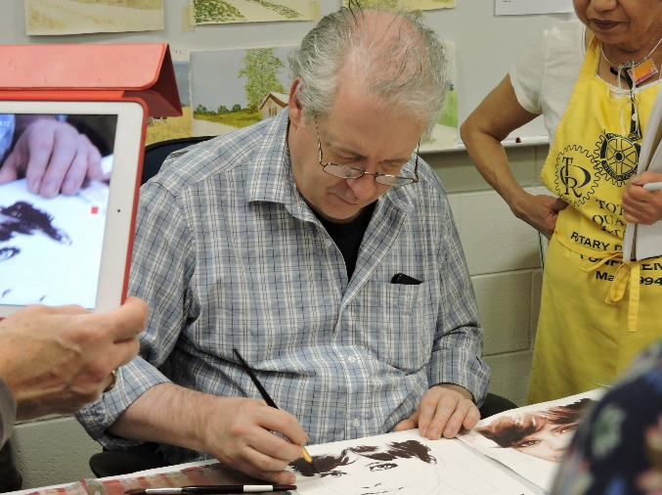
Instructed by: Frank Haddock

Want to try an environmentally friendly paint? Try watercolours! Enjoy expert guidance and individual attention as you explore this exciting medium. Find out how to select paper, paints and brushes to create your paintings. See wonderful demonstrations that will help you learn the many techniques that artists use in their amazing paintings. Learn how to mix a wide range of colours from a limited palette and how to use innovative techniques such as wet-in-wet and dry brush to paint all sorts of images you never imagined you could paint. Your instructor will guide you through many projects, step-by-step instructions as well as wonderful demonstrations. All this and more in what could be the best painting course you've ever experienced. Absolutely no experience in drawing or painting is necessary as the demonstrations and step-by-step instruction will make this a great introduction to painting with watercolours. Check the ELLA website or contact the ELLA office for a supply list. This class is downtown at Enterprise Square (10230 Jasper Avenue). Class capacity: 20.
Frank at Spring Session 2017.

Frank Haddock received a Bachelor of Fine Arts at the University of Alberta. He has taught at Red Deer College, Grant MacEwan University and other cultural centres in Alberta. Frank exhibits art in Vancouver, Calgary, and Edmonton. His work has been in Galleries West Magazine, Edmonton Women’s Magazine and Watercolor Artist Magazine.

EL62 Fabric Surface Design Workshop
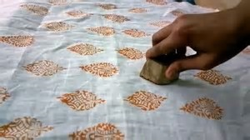
Instructed by: Margie Davidson

The Surface Design workshop will provide a hands-on exploration of colour theory and design principles in the area of surface design – techniques that manipulate or change the surface of a fabric. Students will try a variety of surface design techniques (such as painting on fabric, block printing, stenciling and sun printing) using a non-toxic textile paint on cloth. This course combines both practicing the processes, and completion of finished projects (artist trading cards, fabric postcards, napkins, and scarf). Check the ELLA website or contact the ELLA office for a supply list. This class is downtown at Enterprise Square (10230 Jasper Avenue). Class capacity: 20.

Margie Davidson is a quilt artist and surface designer. Her love of colour is joyfully expressed through the fabrics she paints and the quilts she creates. Teaching is also an important part of who Margie is. She is an entertaining speaker and a supportive instructor. She loves teaching and enjoys sharing ideas about colour theory and design principles to encourage the creation of individual artwork.

Spring Session 2018 Activities
Information on additional activities will be handed out when you pick up your name tag/course information on the first day of Spring Session.

Board Chair’s Greetings and Concert
Monday, April 30 at Noon in the Auditorium (Education N2-115)
Our Board Chair, Joyce Madsen, will welcome participants to Spring Session. Joyce’s remarks will be followed by a musical presentation by the Strathcona String Quartet for your listening pleasure.

Volunteer Appreciation Luncheon
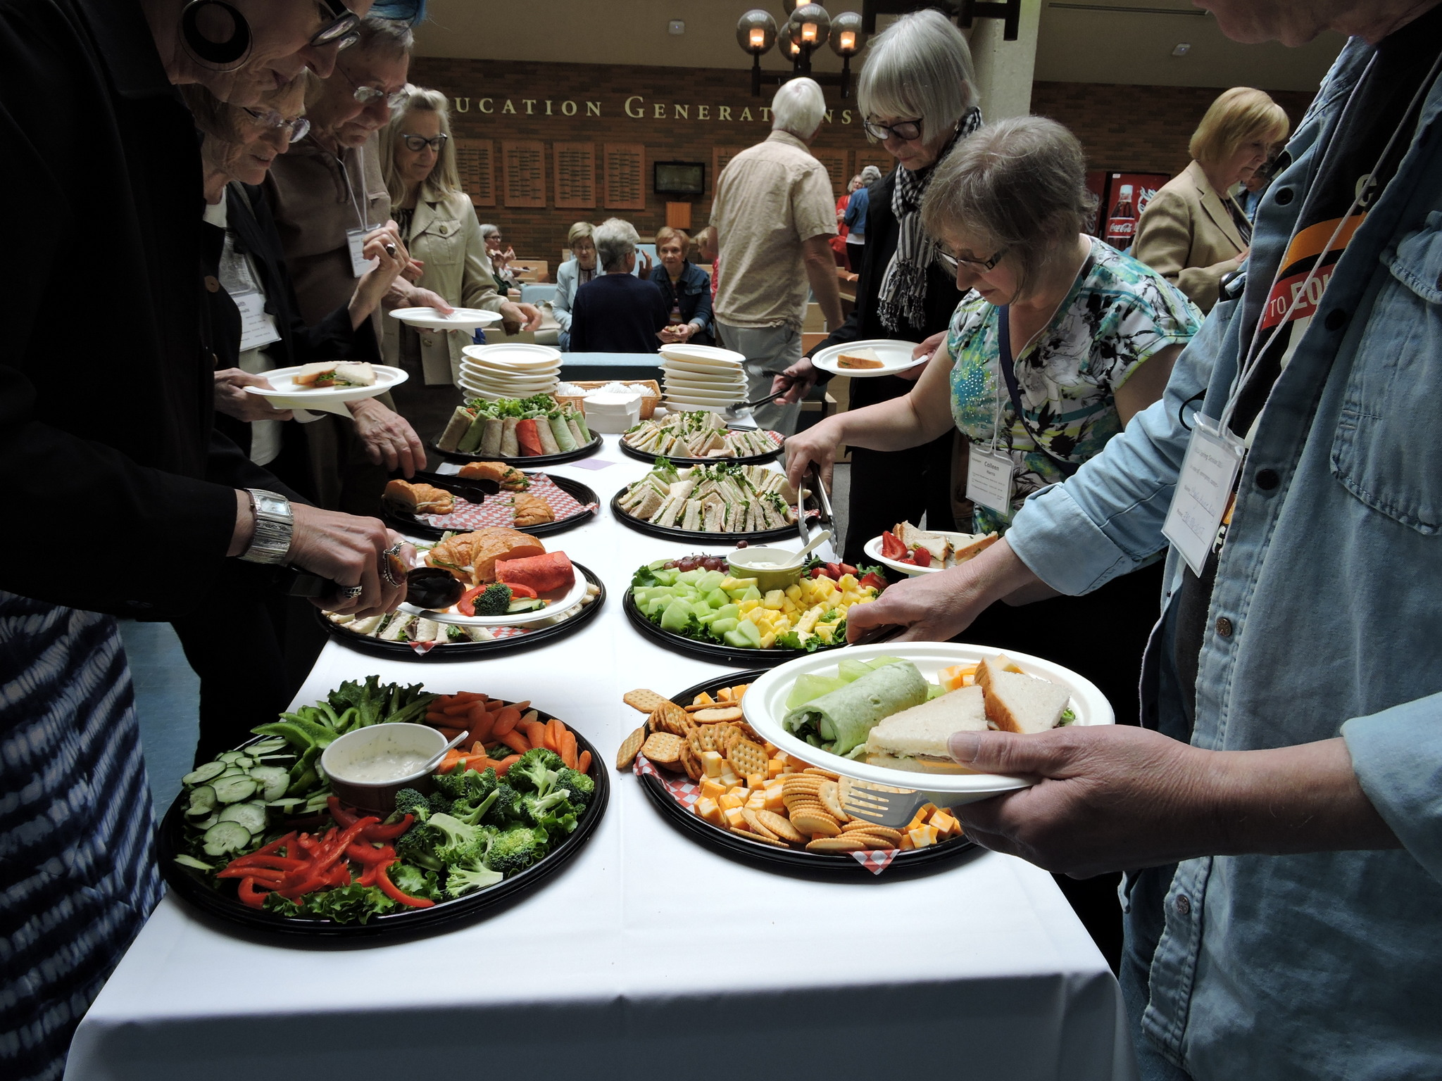
Tuesday, May 8 at 11:45 a.m. (location to be announced).
2017-18 ELLA volunteers are invited to a Volunteer Appreciation Luncheon.

Annual General Meeting and introduction of New Board Volunteers
Thursday, May 17 at Noon in Education N2-115
This is your opportunity to find out about and participate in, the running of ELLA. Hear about our past year’s achievements, meet the Board and the new volunteers to become Board members and vote for the Board of Directors.
Wind-up Party
Thursday, May 17, 4:30 p.m. at the Faculty Club. Tickets can be purchased at the Information Table during Spring Session.

ELLA Walkers
If you would like to enjoy a walk at lunch hour to stretch you legs and refresh you for your afternoon classes, consider joining one of our volunteer-led walking groups. Groups will meet most days at 12:00 Noon at the main entrance to the Education Building, off 87th Avenue. A Schedule of Walks will be posted on the bulletin boards at the ELLA Registration/Information Table. Walks are planned to be no more than about 45 minutes long and be moderately paced unless otherwise specified on the Schedule of Walks.

Spring Session 2018 Noon-Hour Presentations

As noon-hour presentations are often at capacity in N2-115, we ask you to follow these suggestions to help foster an atmosphere of respect for both the presenter(s) and the other members of the audience:
- Please settle into your seat before the session starts at Noon.
- Please turn off cell phones and other related devices and avoid conversing with other members during the presentation. If you must leave your phone on, ensure it is in “silent” mode and leave the room to answer it. Please sit near the door to minimize the disruption as you step out to take your call, and when leaving, hold the door as it shuts to prevent banging.
- To accommodate additional viewers, noon-hour presentations will be live-streamed to room ED129, and on the internet. Additional information will be available at the Information Table during Spring Session.
- If you know you will arrive late, must leave early, will be eating your lunch during the presentation, or will need to answer a phone call at some point during the presentation, please consider enjoying the presentation as it is live-streamed to room ED129 where these kinds of audience activities will not distract the presenters.

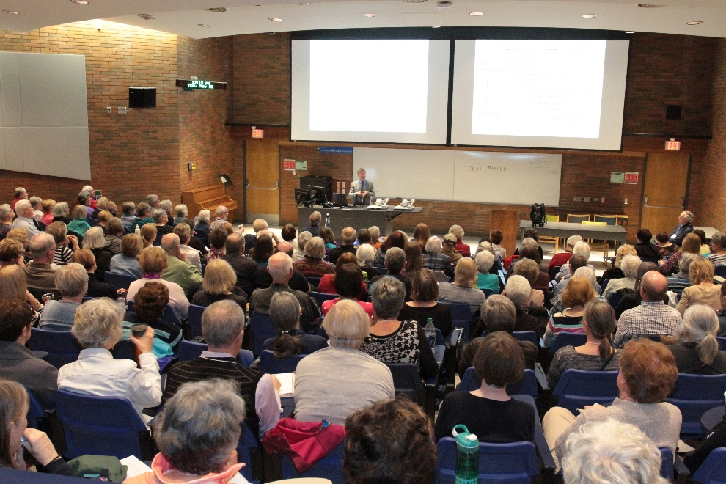

Spring Session 2018 Noon-Hour Presentations
Location: N2-115, Education N / Live-streamed: ED129 Time: 12:00 noon to 1:00 p.m.

Monday, April 30
Strathcona String Quartet: Swinging String Quartet
Josephine Van Lier, Strathcona String Quartet

Tuesday, May 1
The Games Computers (and People) Play
Dr. Jonathan Schaeffer, Professor. Canada Research Chair in Artificial Intelligence, Dean of Science, U of A

Wednesday, May 2
The Canadian Arctic, Sovereignty and Polar Geopolitics
Dr. Mark Nuttall, Professor and Henry Marshall Tory Chair in Anthropology, University of Alberta

Thursday, May 3
De-colonizing Science and Technology
Dr. Kim TallBear, Faculty of Native Studies, University of Alberta

Friday, May 4
How Radioisotopes are Used in Medicine and Improve Patient Care.
Dr. Sandy McEwan, Department of Oncology, Faculty of Medicine, University of Alberta

Monday, May 7
The MacTaggart Art Collection*: Why the University of Alberta Collects (*art and artifacts from East Asia)
Dr. Janine Andrews, Executive Director, University of Alberta Museums

Wednesday, May 9
Beyond the Spin: The Politics and Economics of Alberta’s Carbon Levy
Ricardo Acuna, Executive Director of the Parkland Institute

Thursday, May 10
What Happens when Fashion (Clothing) is Fast, Cheap and Disposable?
Lori Morgan, Assistant Chair of Human Ecology, Faculty of Agricultural, Life and Environmental Sciences, U of A

Friday, May 11
Folkways in Canada: An Introduction to the Smithsonian Folkways Collection from North of the 49th Parallel
Dr. Mary Ingraham, Professor of Musicology, Director of Sound Studies Initiative, University of Alberta

Monday, May 14
Transplant Research: Enhancing Donations and Saving Lives
Dr. Lori West, Director of the Alberta Transplant Institute, Tier 1 Canada Research Chair in Cardiac Transplantation, and Director of the Canadian National Transplant Research Program

Tuesday, May 15
What is an Islamic Garden and What can it Teach Us?
Dr. Lee Foote, Professor of Conservational Biology and Director of the University of Alberta Botanical Gardens

Wednesday, May 16
CKUA: Building Community for Ninety Years Through Music
Ken Regan, Past CEO of CKUA Radio (for 18 years up to 2017)

At a Glance: Activities and Noon-hour Presentations

 | Monday | Tuesday | Wednesday | Thursday | Friday
Week 1  12:00 to 1:00 p.m.  (N2-115) | 30  Strathcona String Quartet | 1  The Games Computers (and People) Play | 2  The Canadian Arctic, Sovereignty and Polar Geopolitics | 3  De-colonizing Science and Technology | 4  How Radioisotopes are used in Medicine…
Week 2  12:00 to 1:00 p.m.  (N2-115) | 7  McTaggart Art Collection: Why the U of A Collects | 8 | 9  Beyond the Spin: The Politics and Economics of Alberta’s Carbon Tax | 10  What Happens When Fashion (Clothing) is Fast Cheap & Disposable? | 11  Folkways in Canada: An Intro to the Smithsonian Collection…
11:45 a.m.  (Location TBA) |  | Volunteer Appreciation Luncheon
Week 3  12:00 to 1:00 p.m.  (N2-115) | 14  Transplant Research: Enhancing Donations and Saving Lives | 15  What is an Islamic Garden & What Can it Teach Us? | 16  CKUA: Building Community For 90 Years Through Music | 17  ELLA  Annual General Meeting | 18
4:30 p.m.  (Faculty Club) |  |  |  | Wind-up Reception

